Contents

69. Understanding Editable Template 2

70. Creating Editable Template 4

71. Editing Editable Template 8

72. Configuring Content policies of editable template in AEM 12

73. Creating a page using Editable Template in AEM 18

# 69. Understanding Editable Template

This feature was introduced in AEM 6.2 version.

With Editable Template, Creating and Developing Template is no longer only developers task.

Developer will be still required to setup an environment, create client library and create the component to be used in the template.

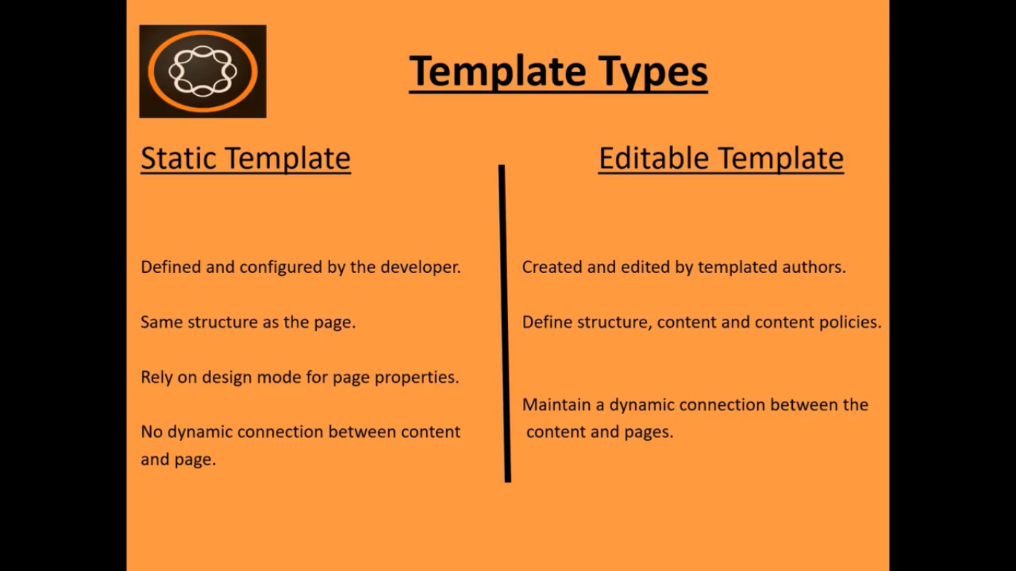

1. **Static Template:**

Defined and configured by the developer. Same structure as the page. Rely on design mode for page properties. No dynamic connection between content and page.

1. **Editable Template:**

Created and edited by templated authors. Define structure, content and content policies. Maintain a dynamic connection between the content and pages.

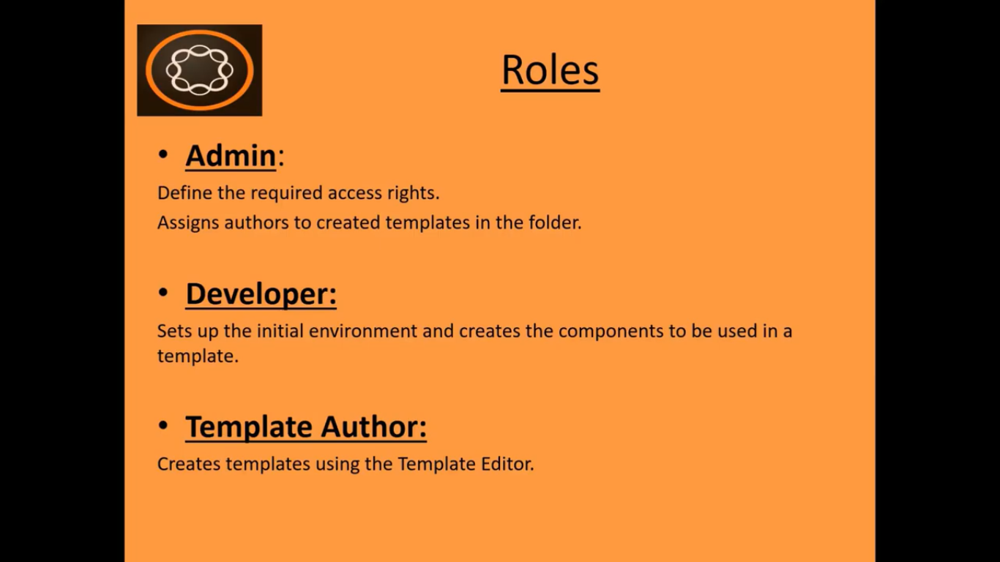

**Roles:** Creating a new template using the template console requires collaboration between admin, developer ad template author.

**Admin:** Define the required access rights. Assigns authors to created templates in the folder.

**Developer:** Sets up the initial environment and creates the components to be used in a template.

**Template** **Author:** Creates templates using the Template Editor. Configure the use of the component in a page. Template authors are part of the members group which allocates the required privileges and permission to author these templates.

While using Editable templates you will use below 3 modes.

1. **Structure**

Which components a template can hold.

1. **Initial Content**

This mode is what initial content for each of these component should be in.

For example, you can put pre-defined text in text component or images in the images component to look like initial content.

1. **Layout**

In this mode you can define how the layout goes based on the device format.

# 70. Creating Editable Template

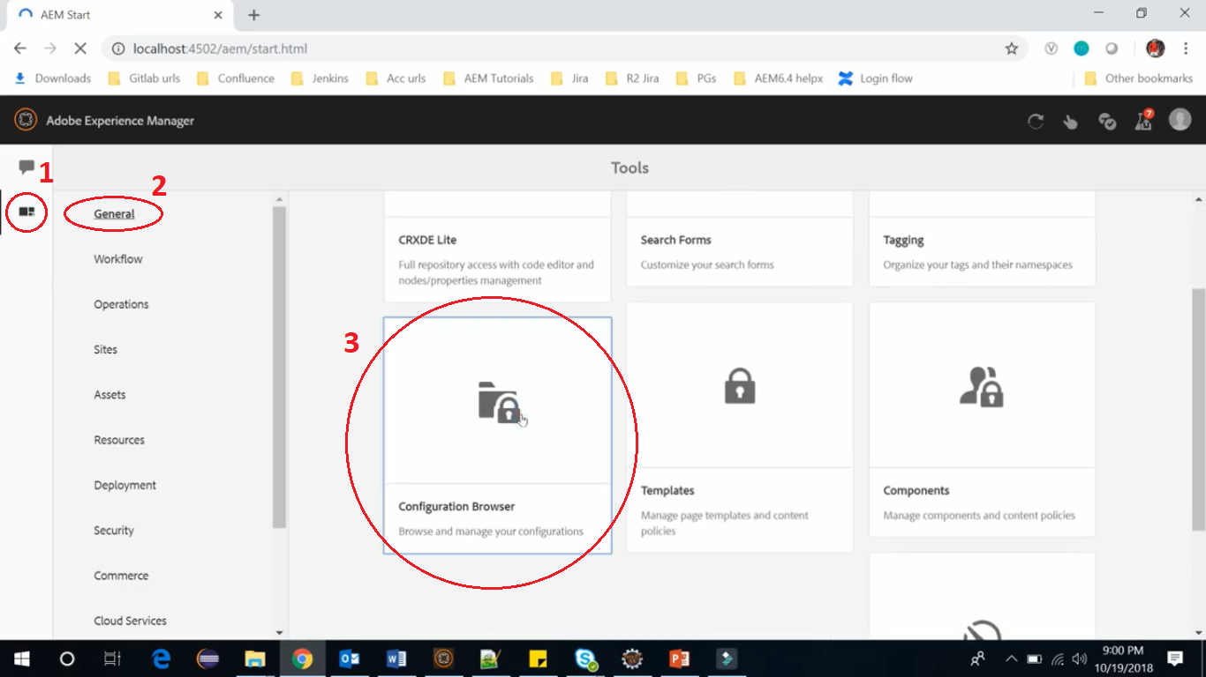

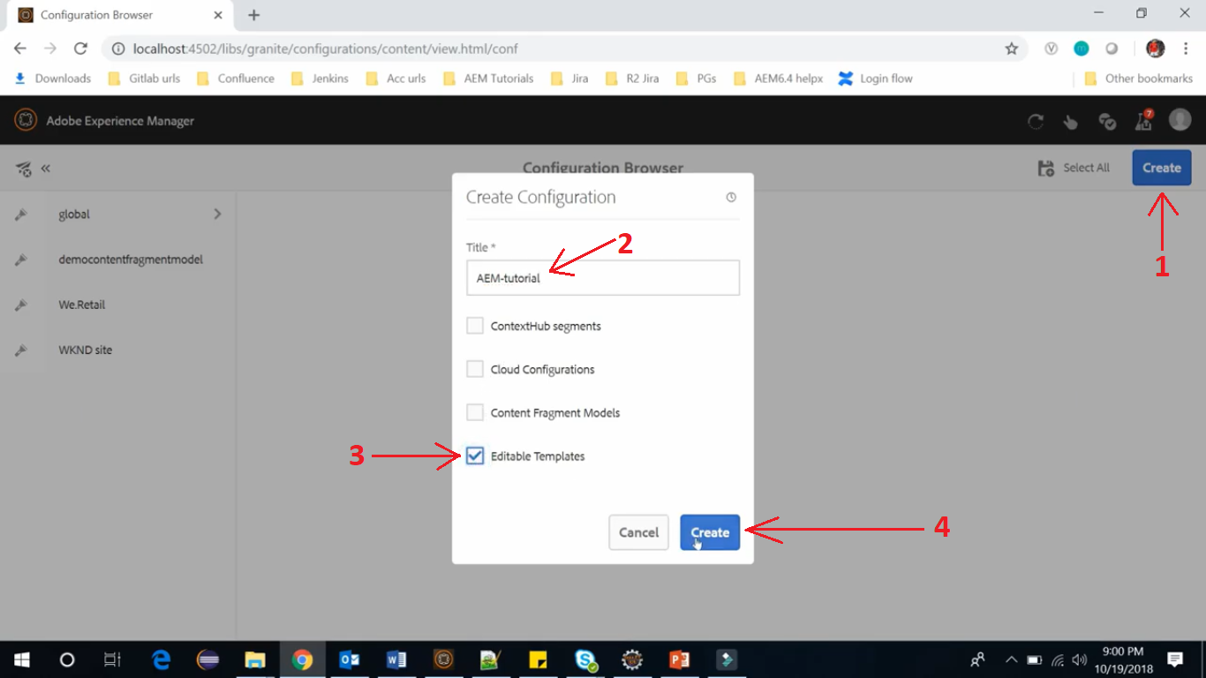

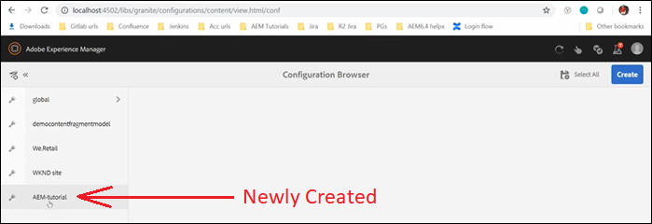

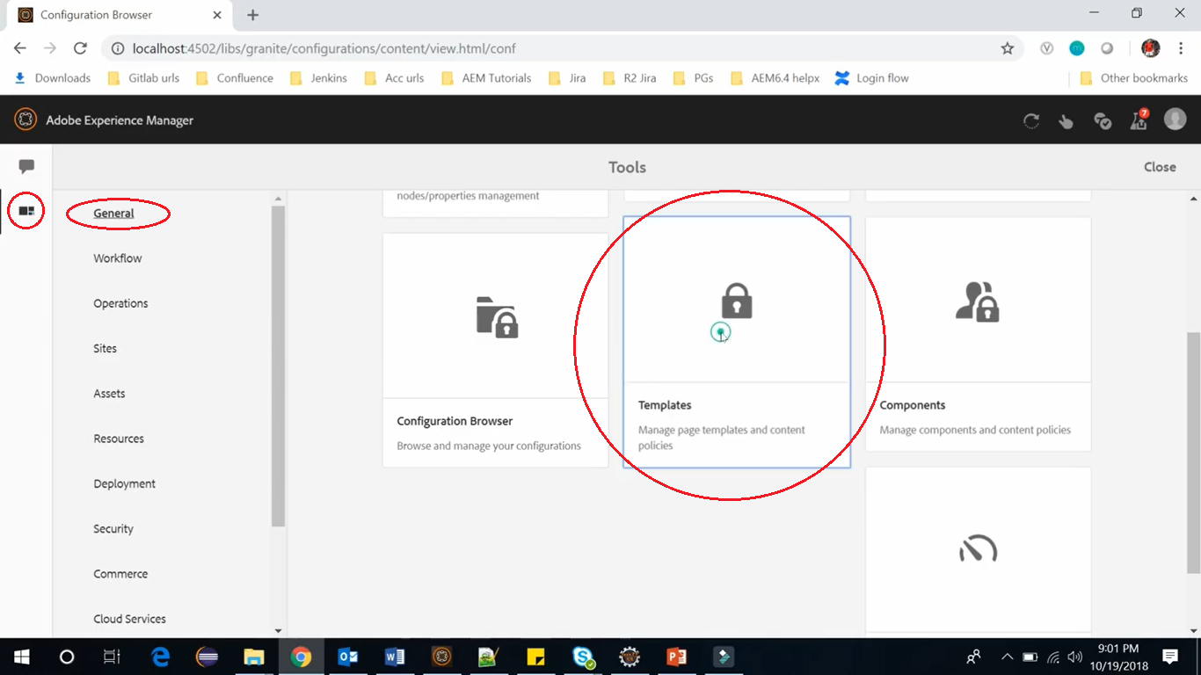

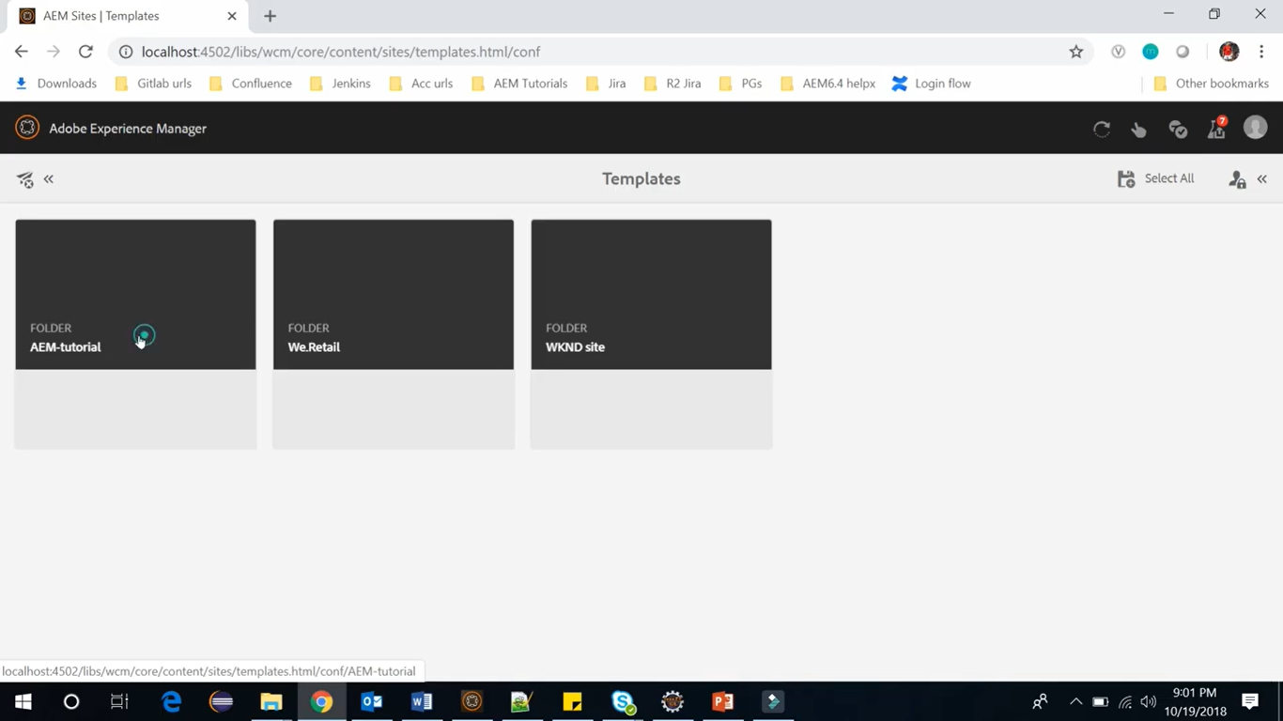

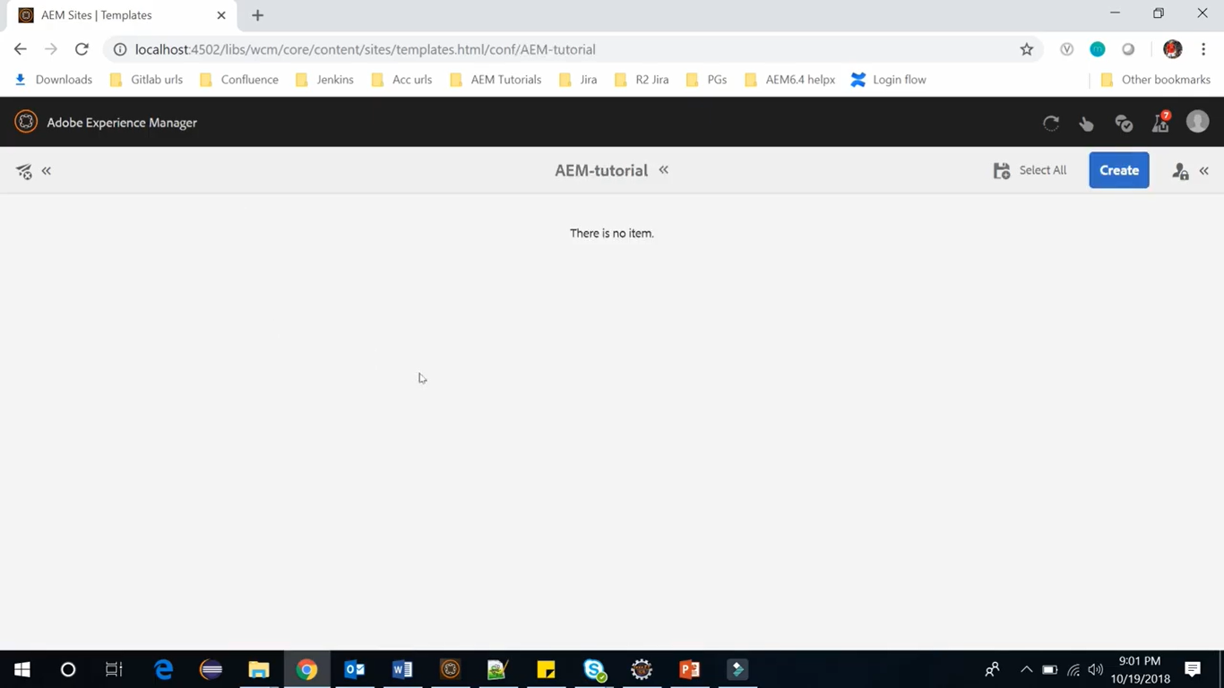

We can create Editable Template here.

You can also see in below image that in CRX/DE, you can see that a new folder named **AEM-tutorial** has been created at path under root **conf** folder**.**

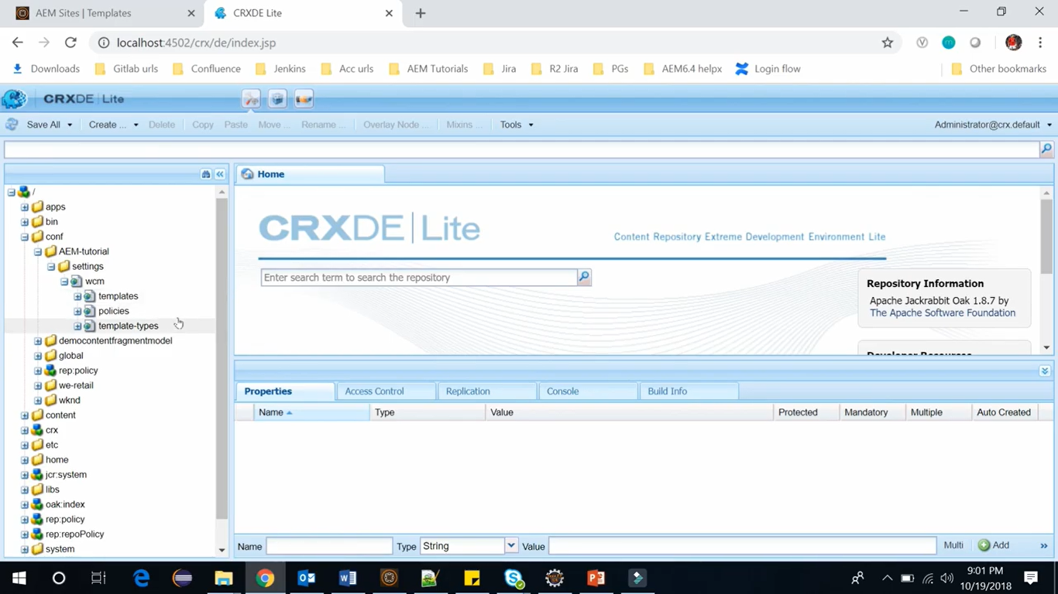

Go back to our newly created Template, to create Editable Template using following steps.

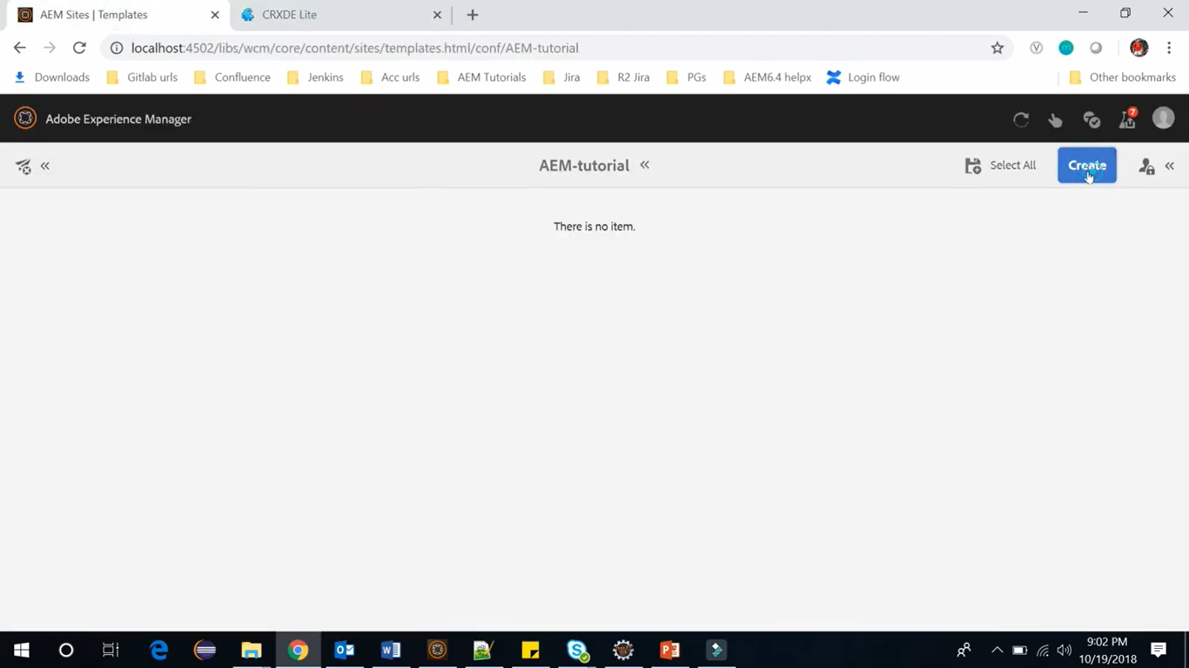

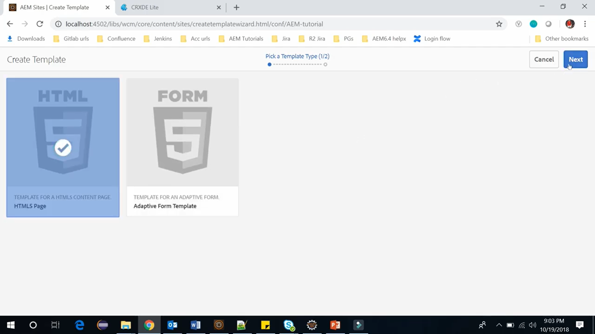

These templates from above screen are called template types. The editable templates are going to be based on one of these templates. Select one of the templates from above screen (lets select HTML5).

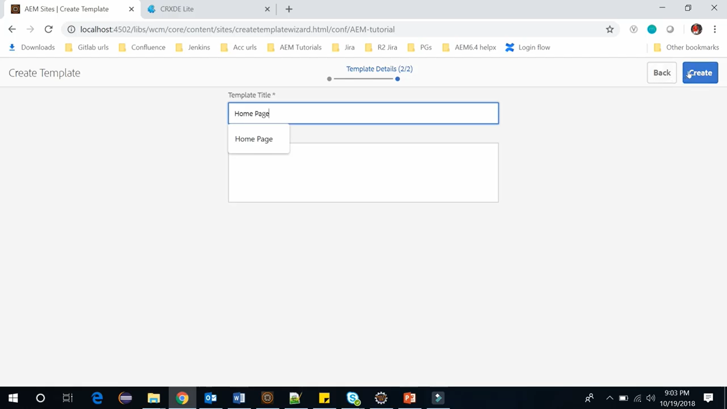

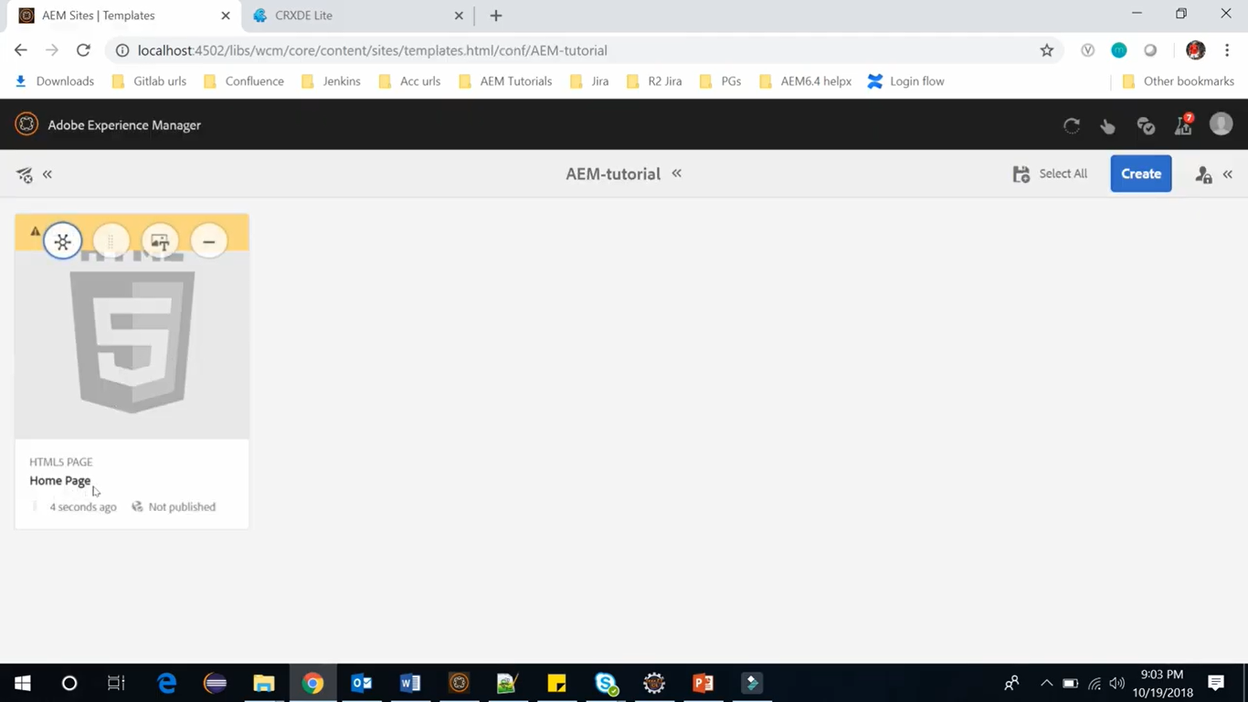

Refresh node **/conf/AEM-tutorial/settings/wcm/templates/home-page**

You will see the entry of new Editable Template i.e. node named **home-page**.

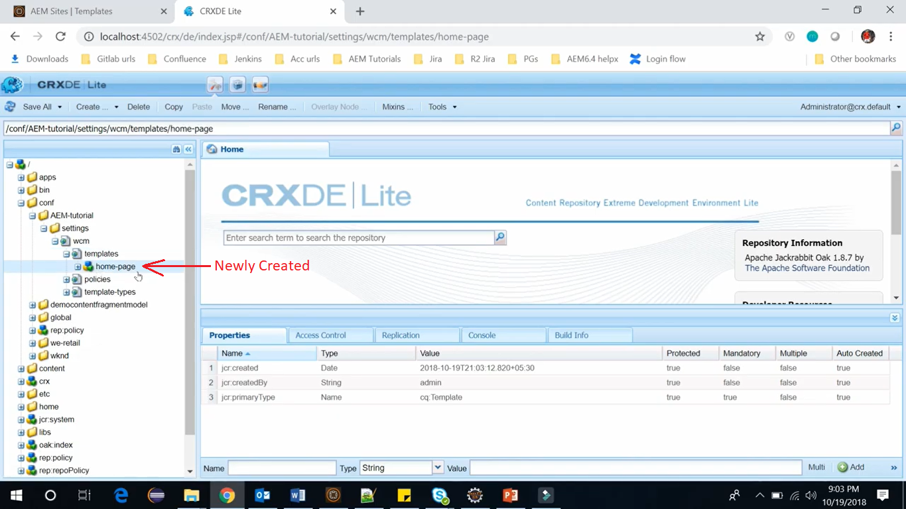

If you select this Editable Template and click in Edit icon on Toolbar (cursor shown in image), it will open the **Template Editor** at below URL where a **Template Author** can edit the template.

<http://localhost:4504/editor.html/conf/AEM-tutorial/settings/wcm/templates/home-page/structure.html>

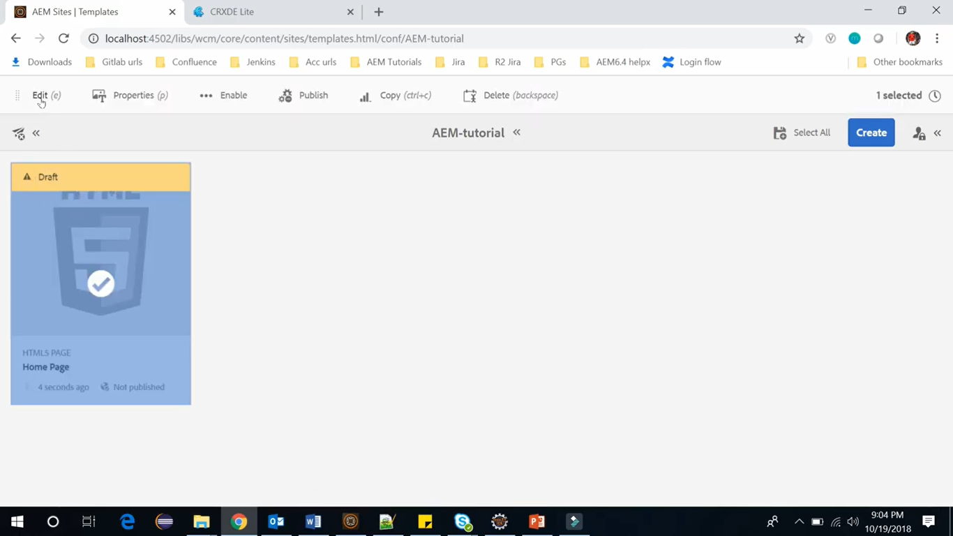

# 71. Editing Editable Template

**Step 1:** Click on Edit icon (see cursor pointer). It will open our template in template editor.

<http://localhost:4504/editor.html/conf/AEM-tutorial/settings/wcm/templates/home-page/structure.html>

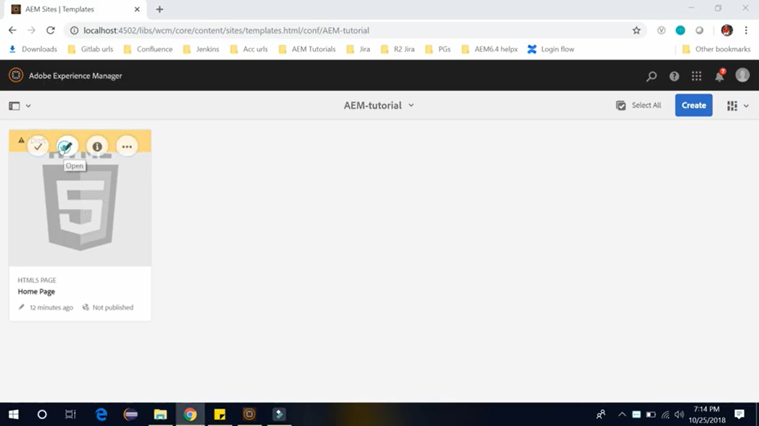

**Step 2:** Here we will see blank template and we will fill it with different components to define the page structure. You can see there are total 3 modes in this template editor (see cursor pointer).

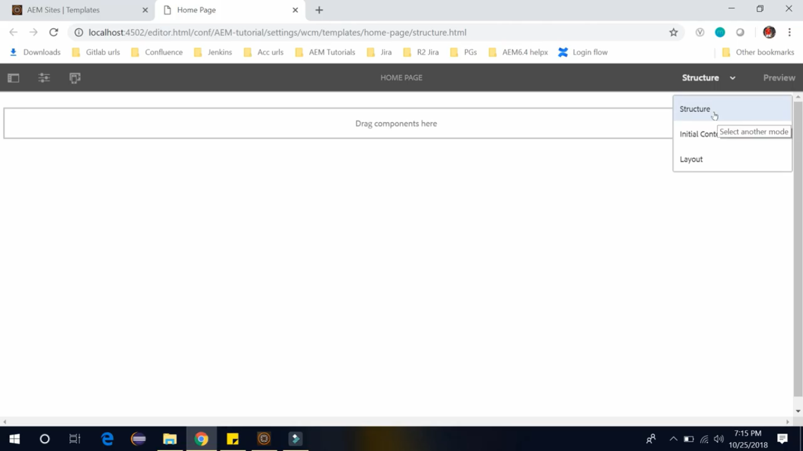

**Structure mode:**

It is to building structure with components. Here components can be either locked or unlocked. When components are locked, you can add content, but page author cannot edit the component.

**Initial Content mode:**

You can unlock component to allow you to define initial content. In this mode you can define initial content of the component, if it is unlocked and that will be copied to any page based on this template.

**Layout mode:**

Here you can predefine the template layout for the different devices. The layout container allows you to use responsive grid

Let’s get started with structure mode and let’s define structure of this template.

**Step 3:** Click on “Drag components here” section. Click on Add component icon.

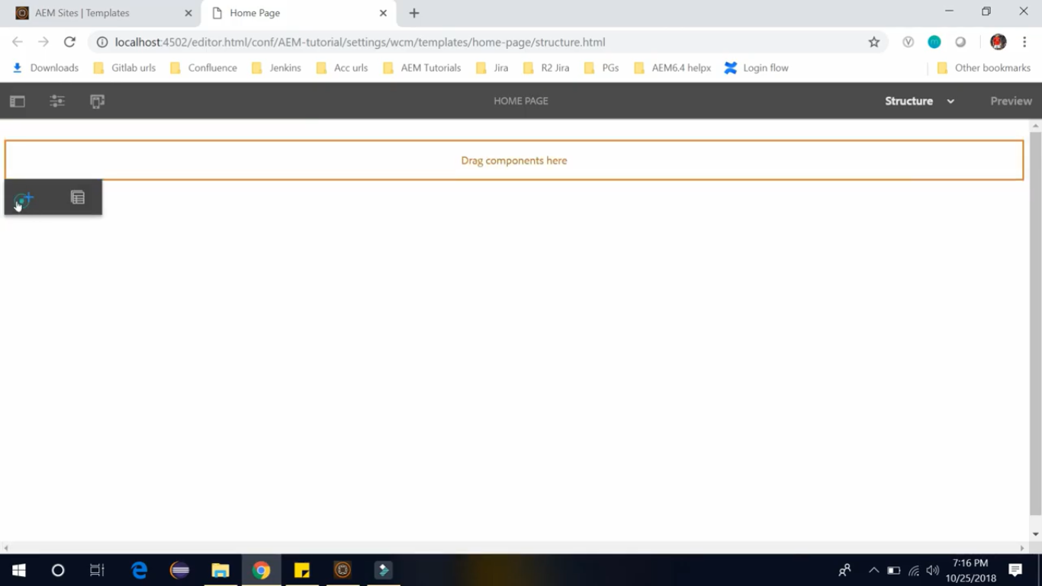

**Step 3:** Type “Title” to search and select **Title – HTL** component to insert the component.

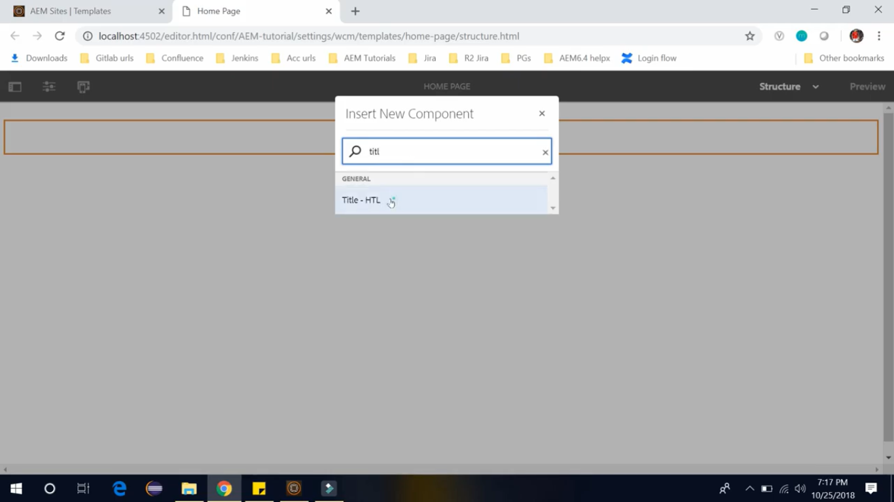

**Step 4:** Type “Image” to search and select **Text & Image – HTL** component to insert the component.

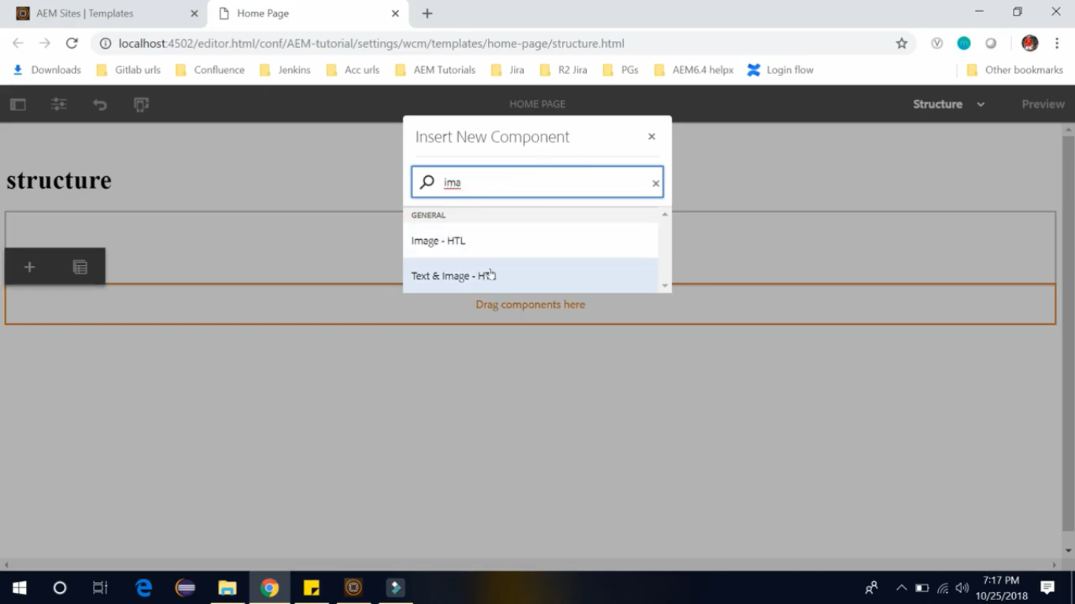

**Step 5:** Type “Text” to search and select **Text – HTL** component to insert the component.

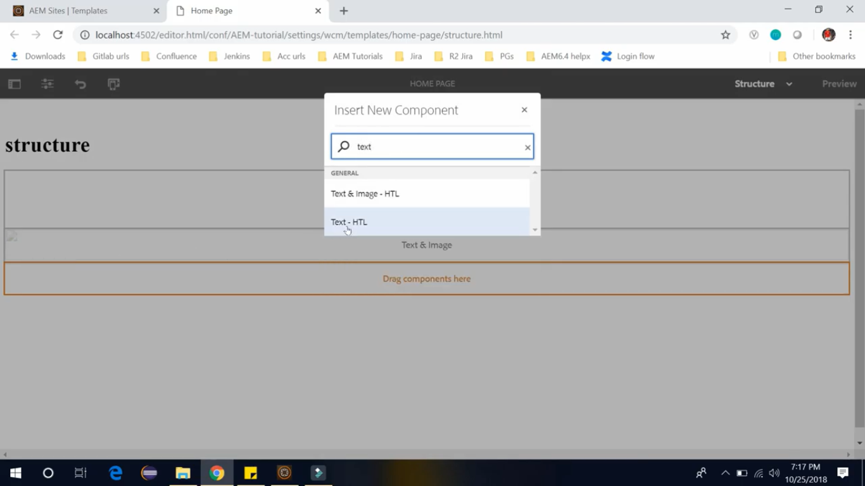

**Step 6:** Edit the last component, **Text – HTL** component, to add text “Footer copyright”, make it bold and centred.

**Step 7:** Now Title (with text as structure) and Footer (with text as Footer copyright) is ready.

Now we will keep the Content Fragment section in 2 columns.

Click on **Layout icon** (see cursor pointer). Drag the endpoint of Content Fragment section till 600px.

**Repeat** same steps for **Text & Image** component, so that both components will appear in same row.

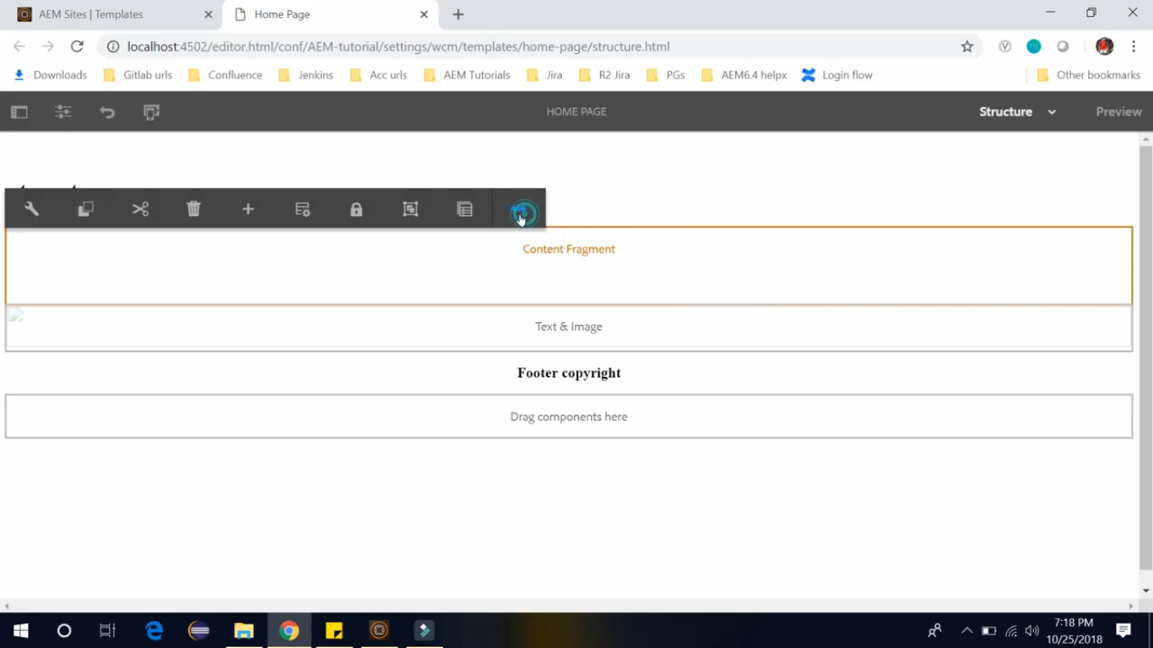

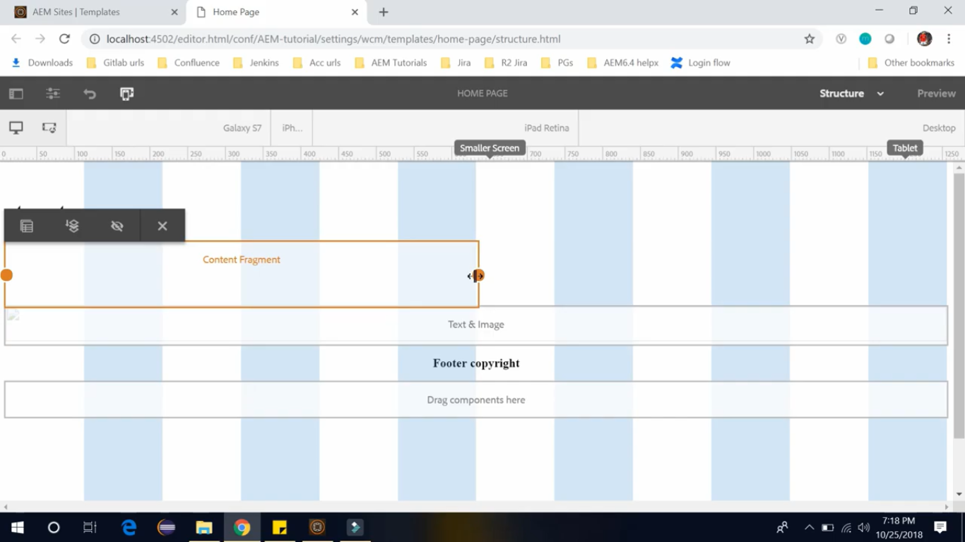

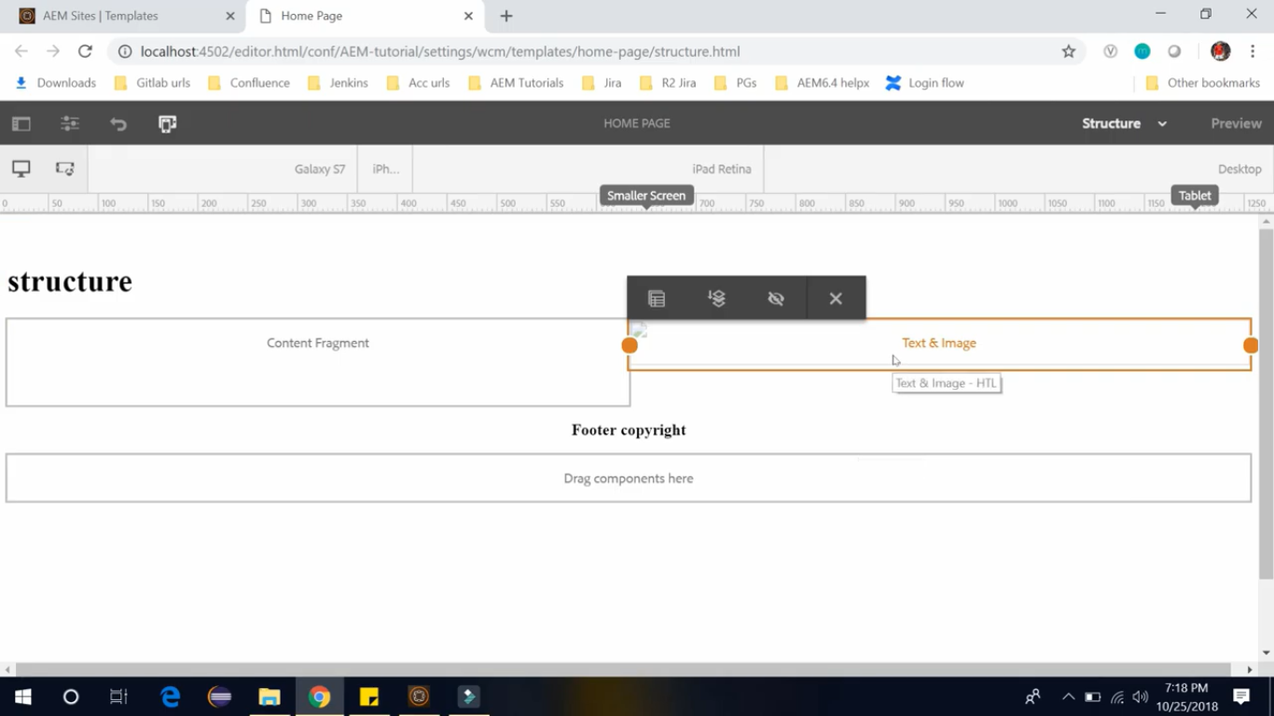

**Step 8:** Now we don’t want page author to edit this **Title** component (text as **structure**) and **Footer** component. But we want page author to be able to edit **Content Fragment** and **Text & Image** component.

Click on **Content Fragment,** click on Unlock icon (cursor pointer) and repeat for **Text & Image** component.

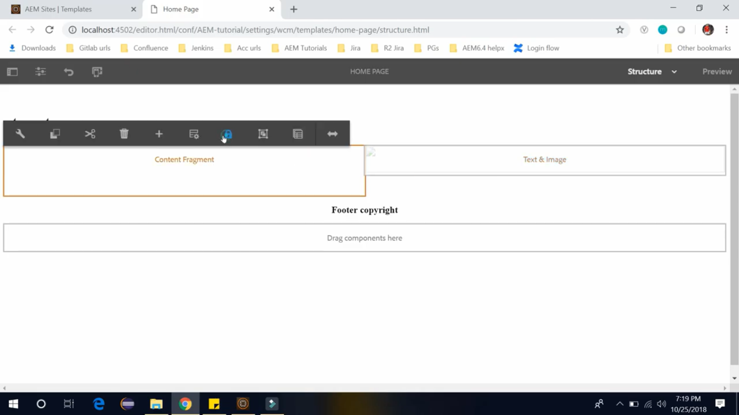

**Step 9:** Once both components are unlocked, switch to **Initial Content** mode.

You can see that you can edit **Content Fragment** and **Text & Image** component but not able to edit **Title** component and **Footer** component. **Edit** to add content in these components.

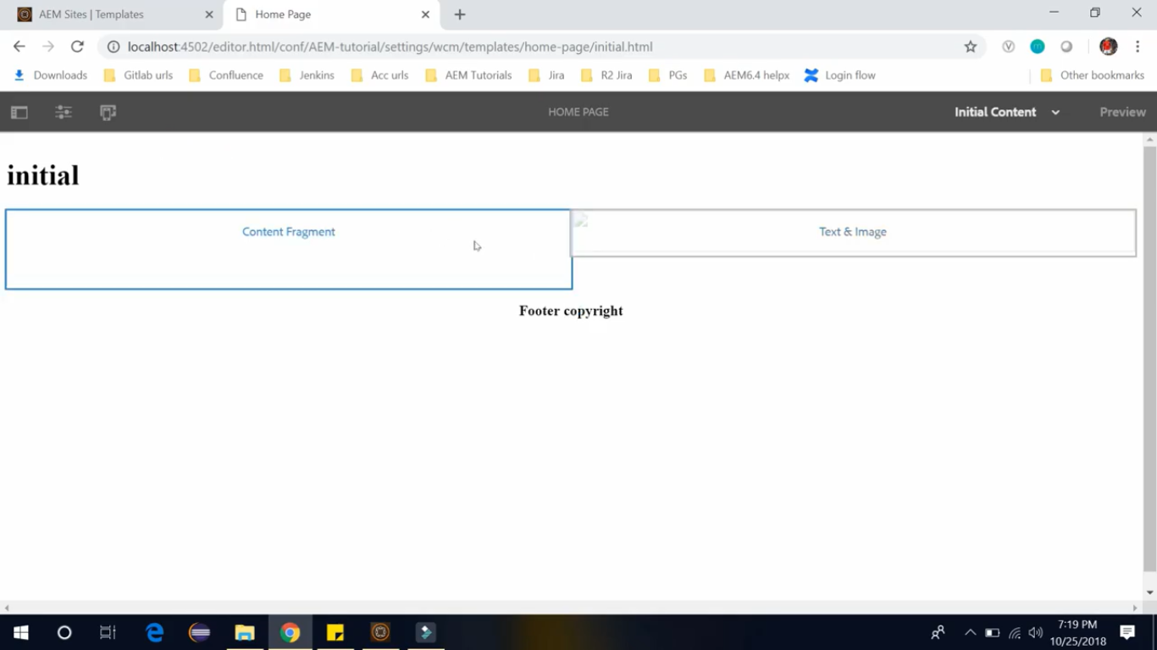

Once you have added content in these components, switch to Layout mode, where you can edit the Layout of the template and adjust width of the components. This way you can create layout of editable template.

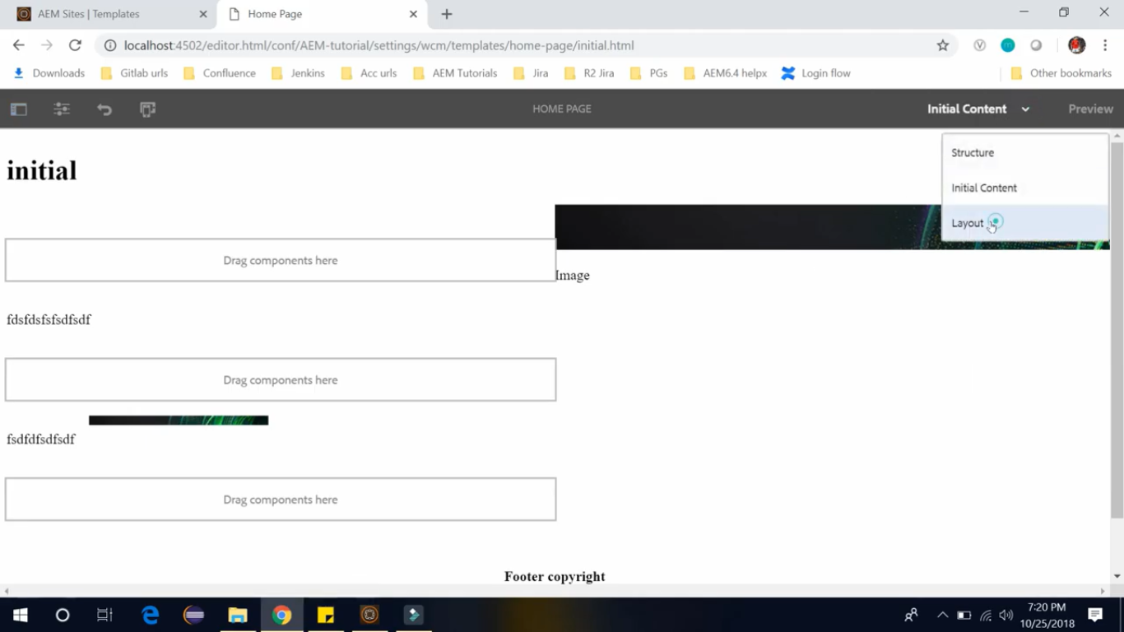

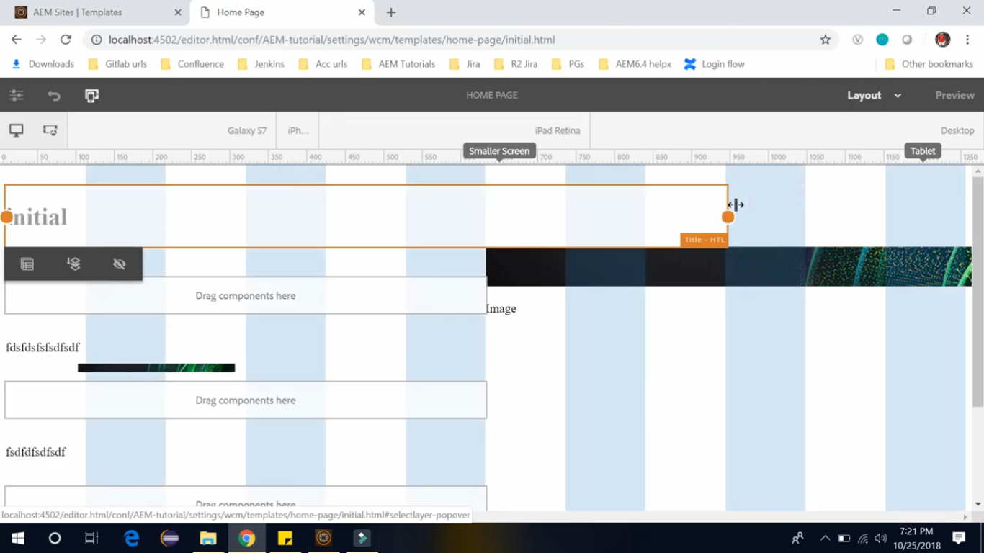

# 72. Configuring Content policies of editable template in AEM

Let’s open home page template. <http://localhost:4504/editor.html/conf/AEM-tutorial>

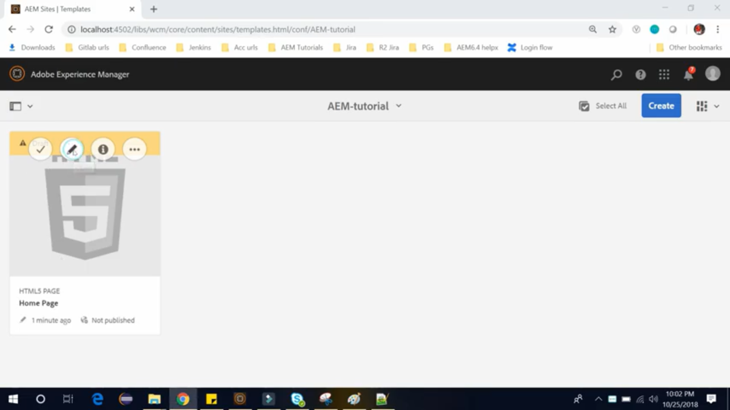

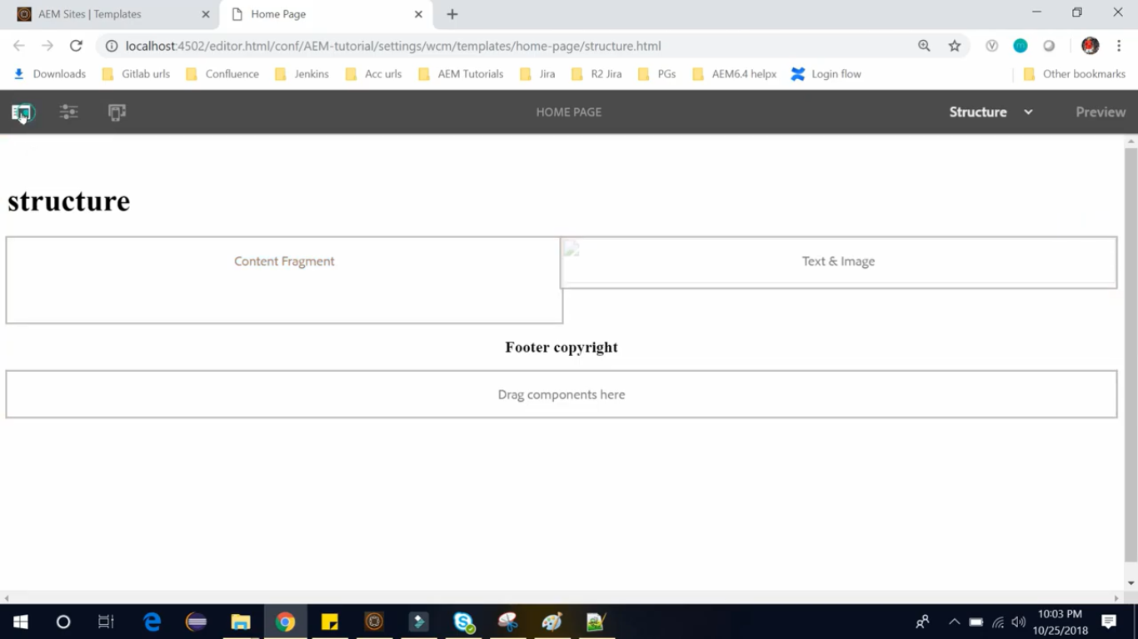

When you have a page, you have a mode called design mode. But in this editable template we have policies using which you can define design properties of a component.

**For Example:** what are components allowed from page author to author. So, using this content policies we can define the components which will be allowed for the page author. Drag and drop **2** **Layout Container**.

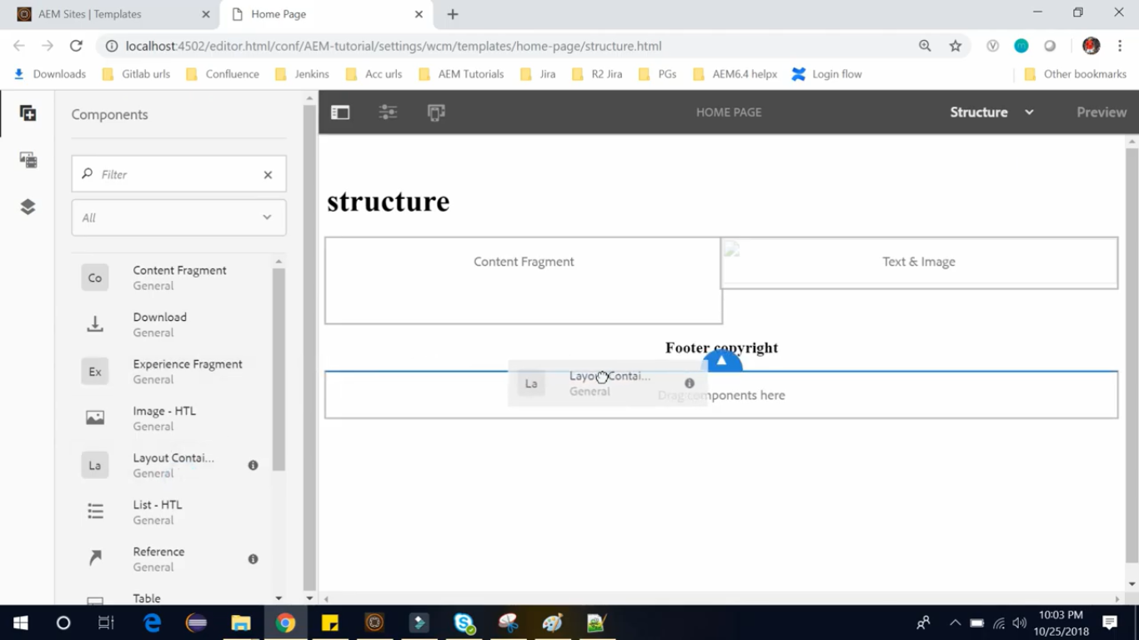

So, now we have 2 layout containers (below image) on which we can define the content policies.

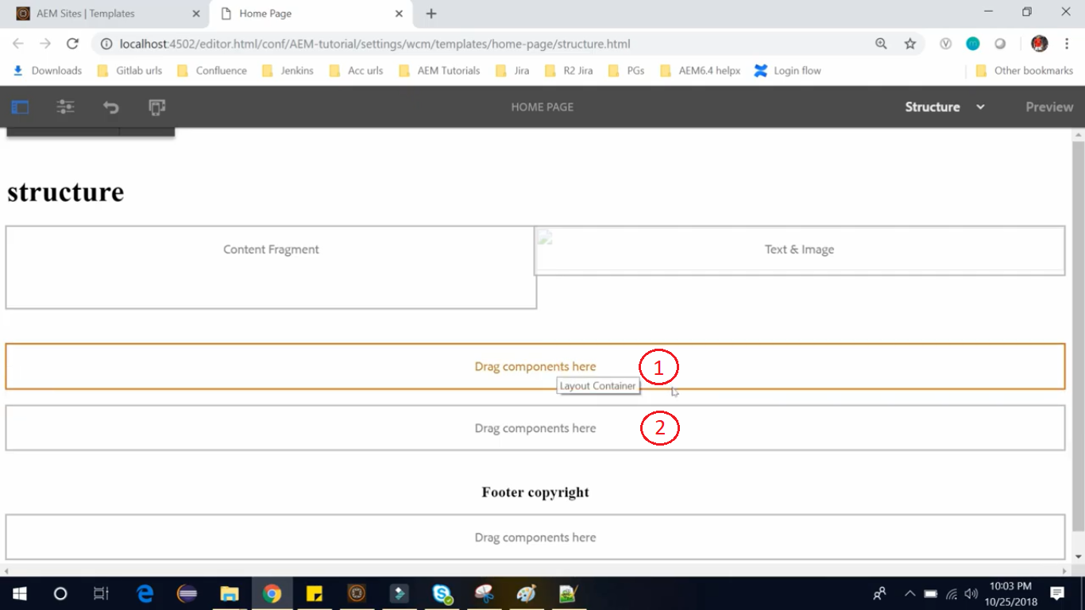

Now unlock these layout containers by clicking on these and then clicking **Unlock** icon (see cursor pointer).

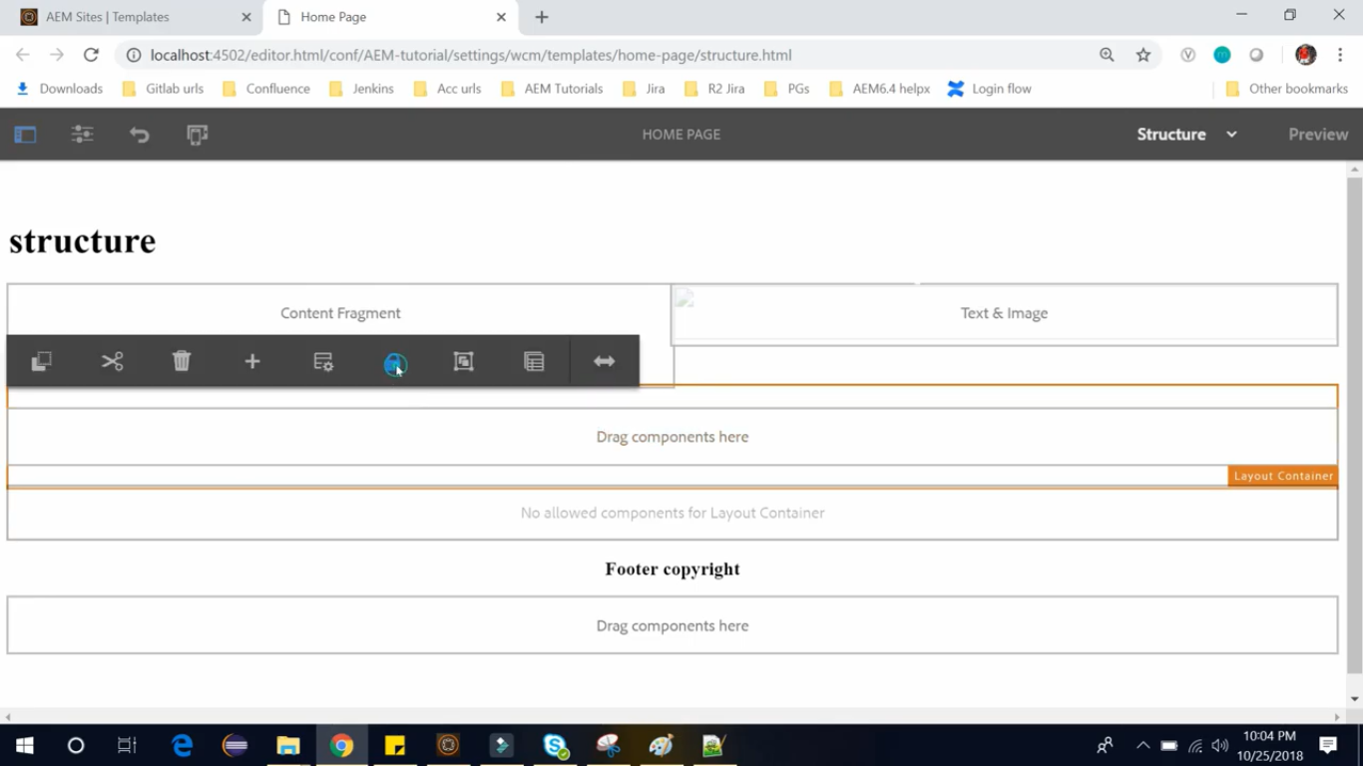

Now select the **first Layout Container** and click on **Policy** icon (see cursor pointer).

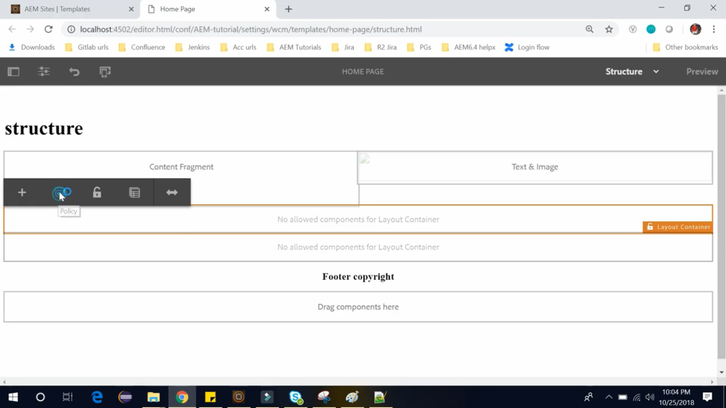

It will open a window where you can create new policy. So, name your policy in this window.

Let’s say we want to only allow the **video** **component** in that **first Layout Container.**

So, we will set below fields and select below highlighted checkbox. Click on **√** **confirm** **icon** (at upper right)

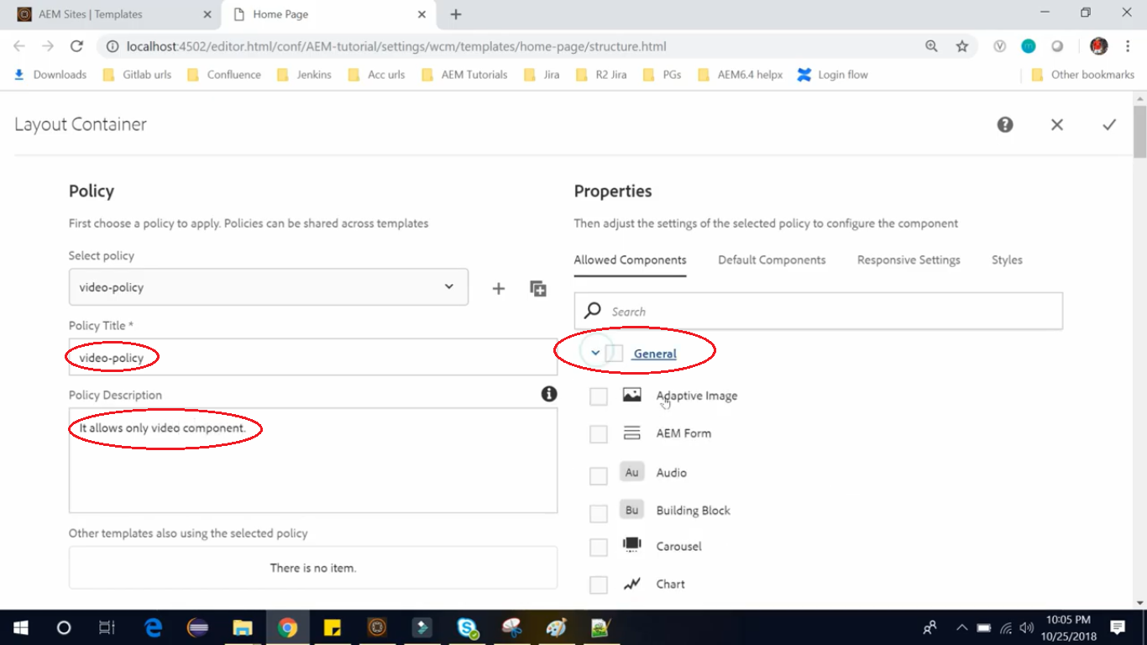

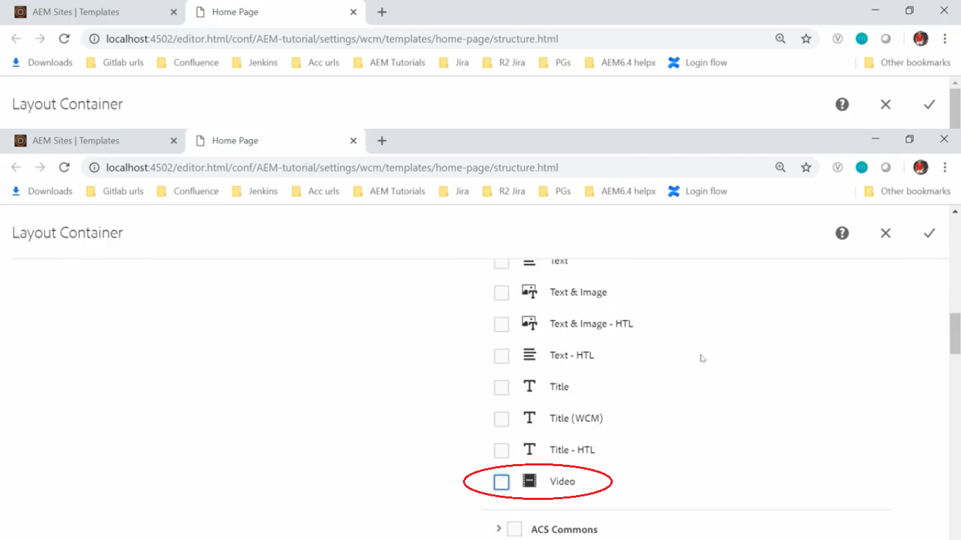

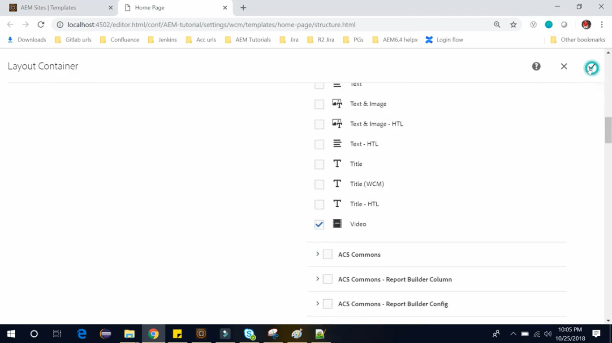

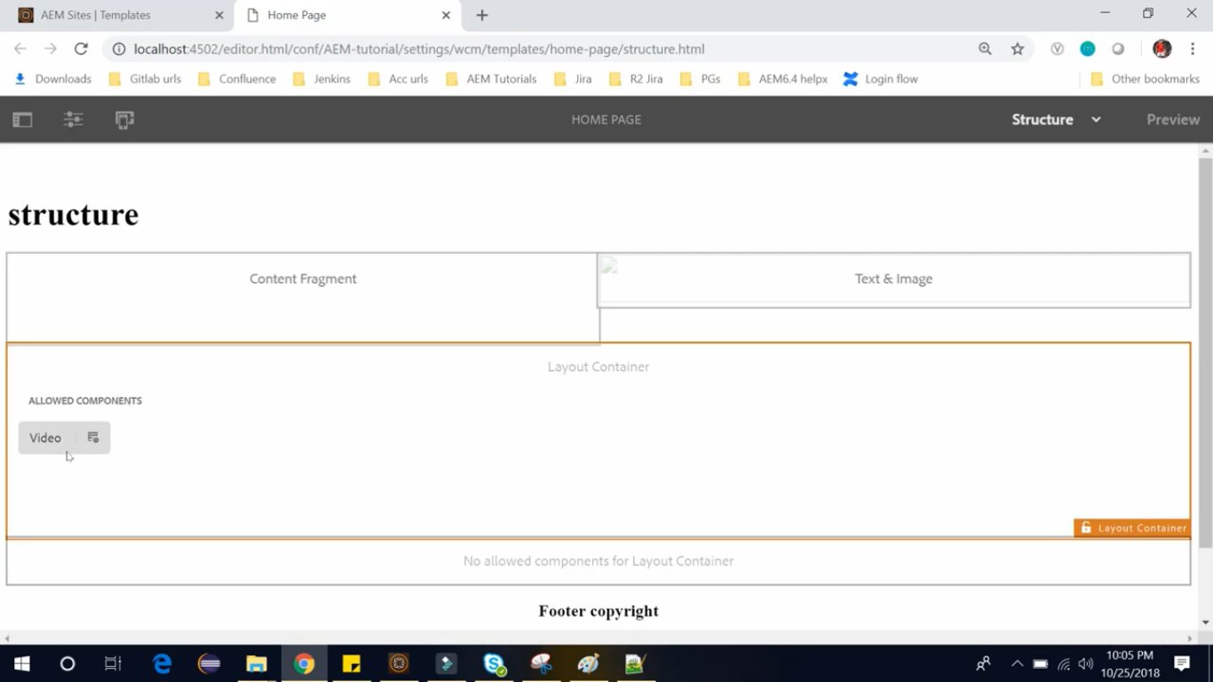

So now we can see in above image, **ALLOWED COMPONENTS** is set to only **Video.**

So, it will only allow the **Video component** for the **page author** to author in this **Layout Container**.

While in the **second Layout container**, we want to allow only **Images.**

Now select the **first Layout Container** and click on **Policy** icon (see cursor pointer).

now for Second container do same procedure but for Image.

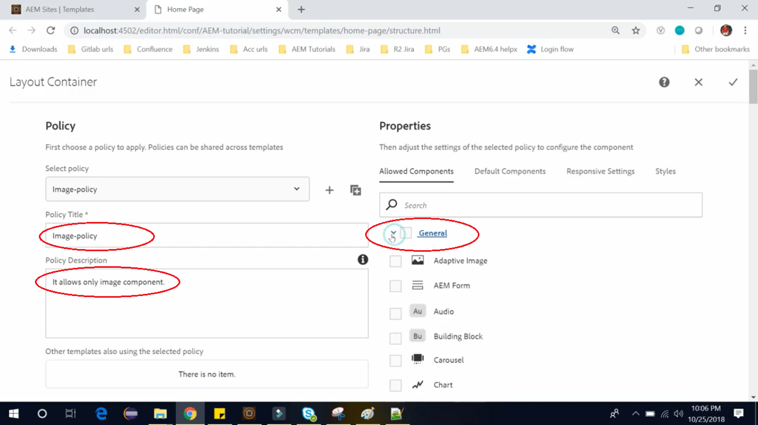

So, we will set below fields and select below highlighted checkbox.

And inside **Allowed Components** Tab, from **General** group, select **Text and Image**, **Text and Image-HTL**, **Image**, and **Image –HTL** and Click on **√** **confirm** **icon** (at upper right).

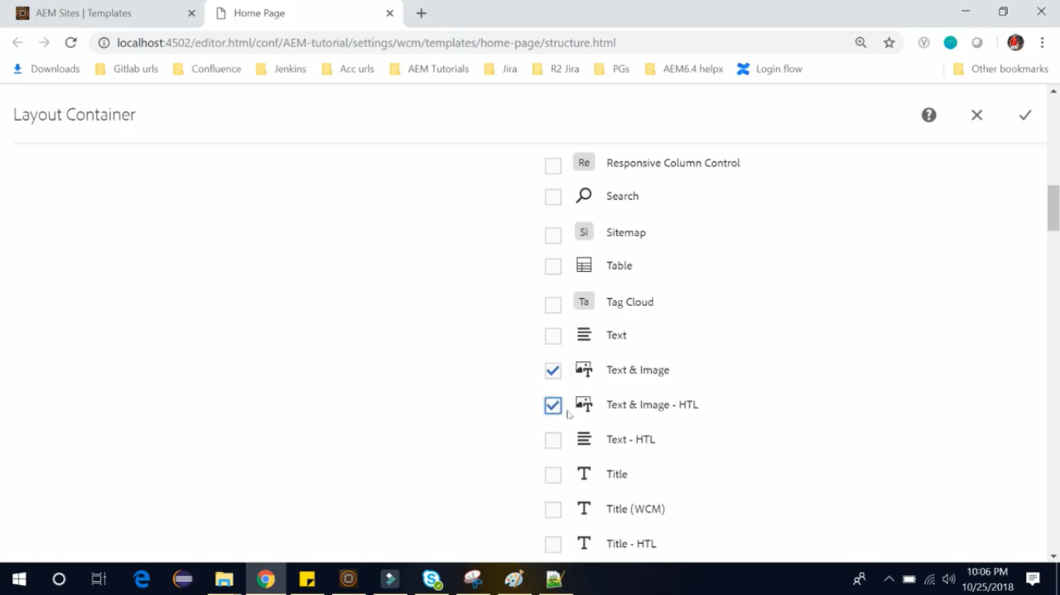

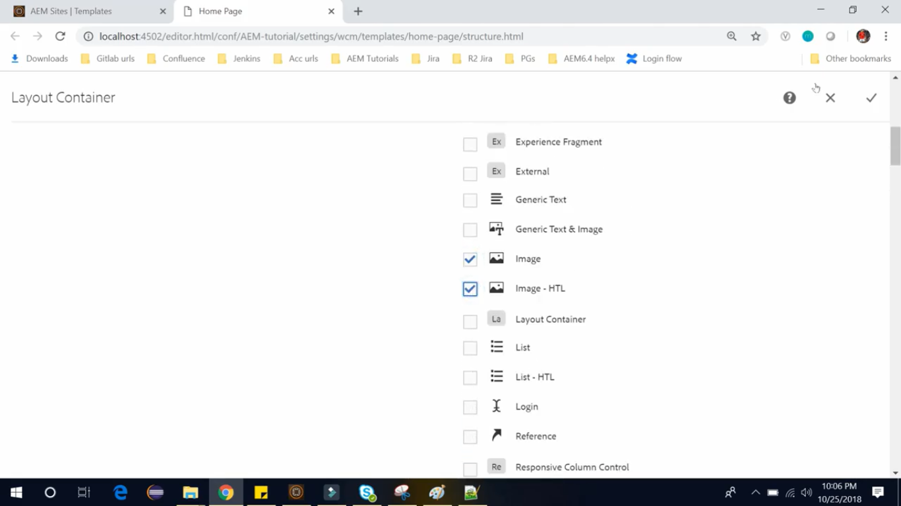

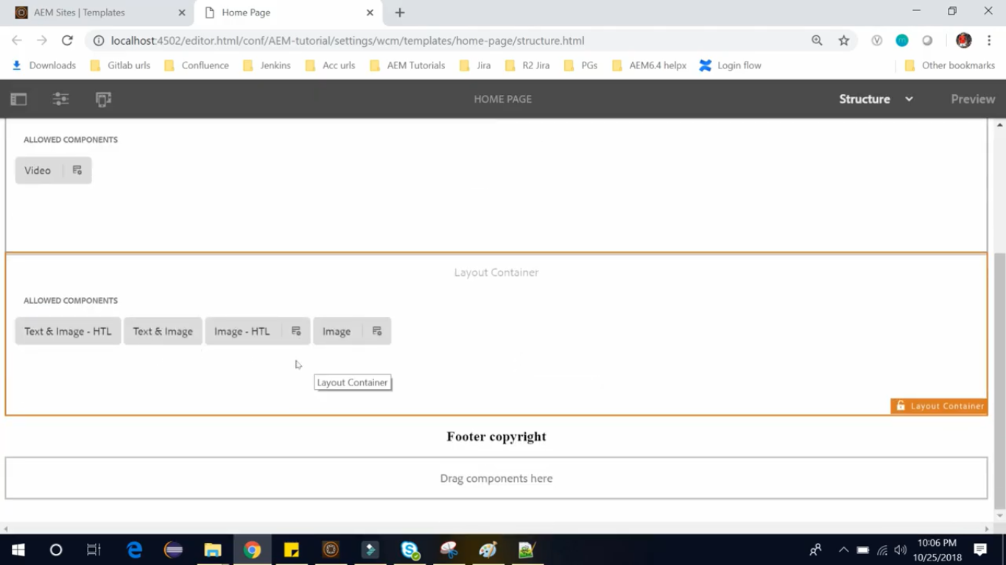

So now we can see 4 components related to images in above image. It will only allow these 4 components for **Page Author** to author in this **Layout Container.**

Once you are done with the policies and the structure of your editable template, go back to the template console and refresh It. [http://localhost:4504/editor.html/conf/AEM-tutorial](http://localhost:4504/editor.html/conf/AEM-tutorial/settings/wcm/templates/home-page/structure.html)

And we need to enable it before creating any page from the template using steps shown in below images.

Now it will be available to create page from this template.

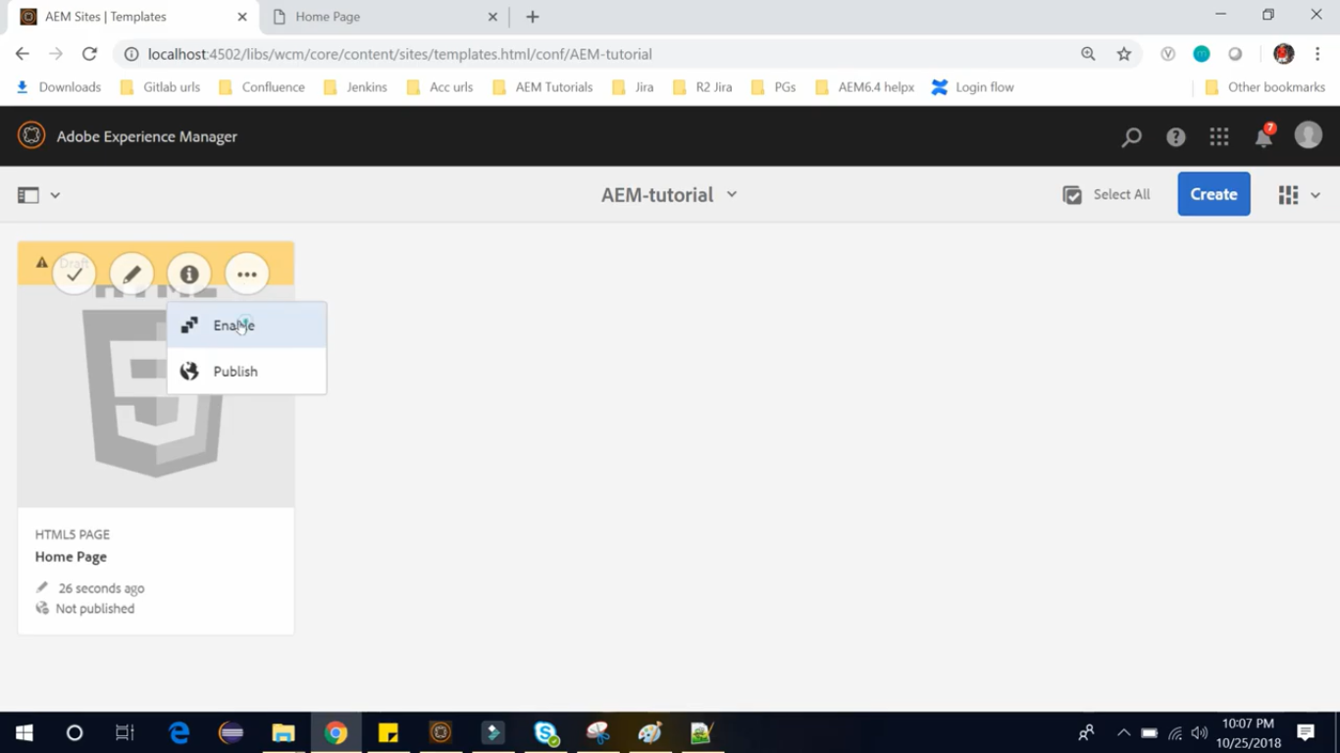

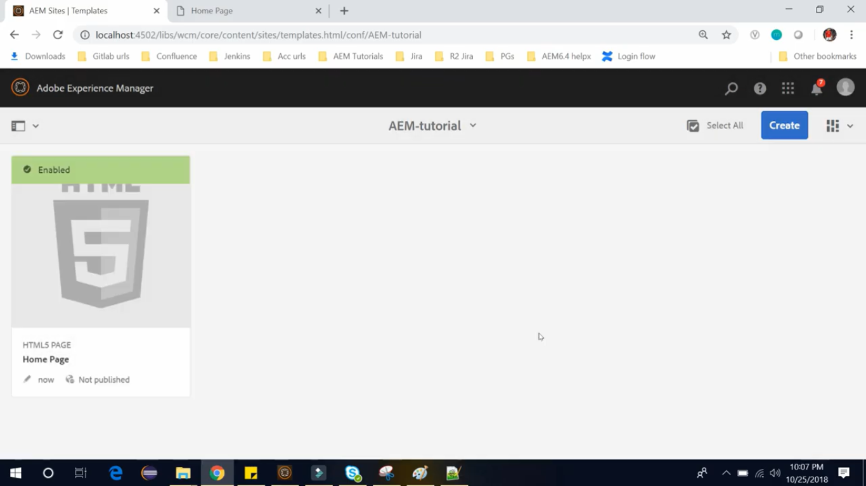

# 73. Creating a page using Editable Template in AEM

In last section, we have **created** the structure of this Editable Template and then **enabled** the Editable Template so that we can use this in the page.

In this section, we will see how we will **create page using editable template**.

Let’s do this, go to the site console. <https://localhost:4502/sites.html/content>

Click DemoSite --> Click English --> Click **Create** button --> There’s no option for **Page**

That means none of the Template is available to create a page here.

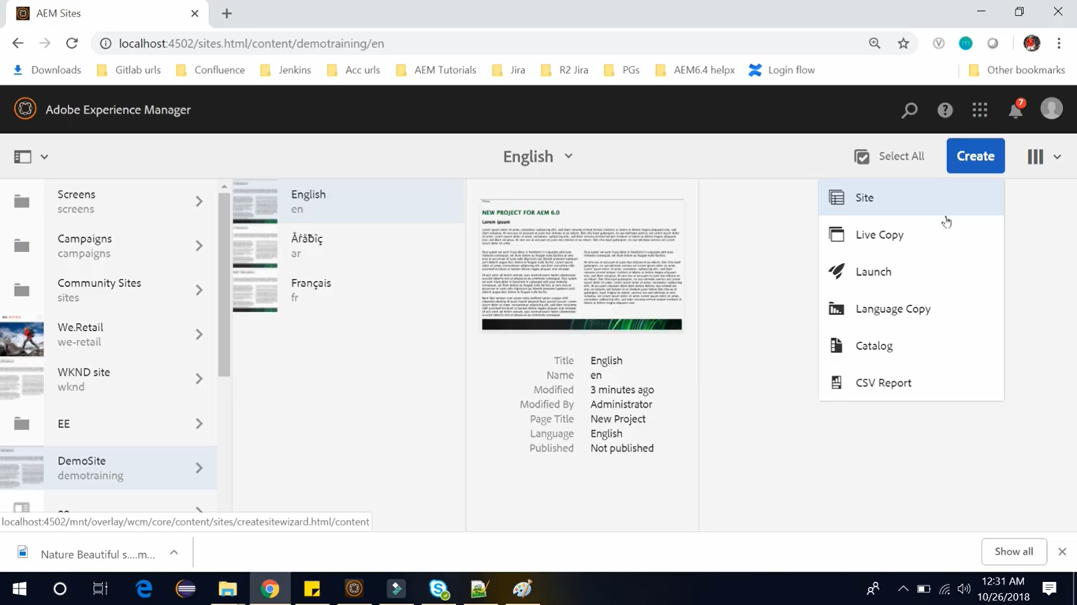

Now In above Image we **cannot** see an option to create a page, but see other options (Site, Launch, etc.)

To get that option, Click on **English** page, click **Properties** icon from Toolbar at top of the page.

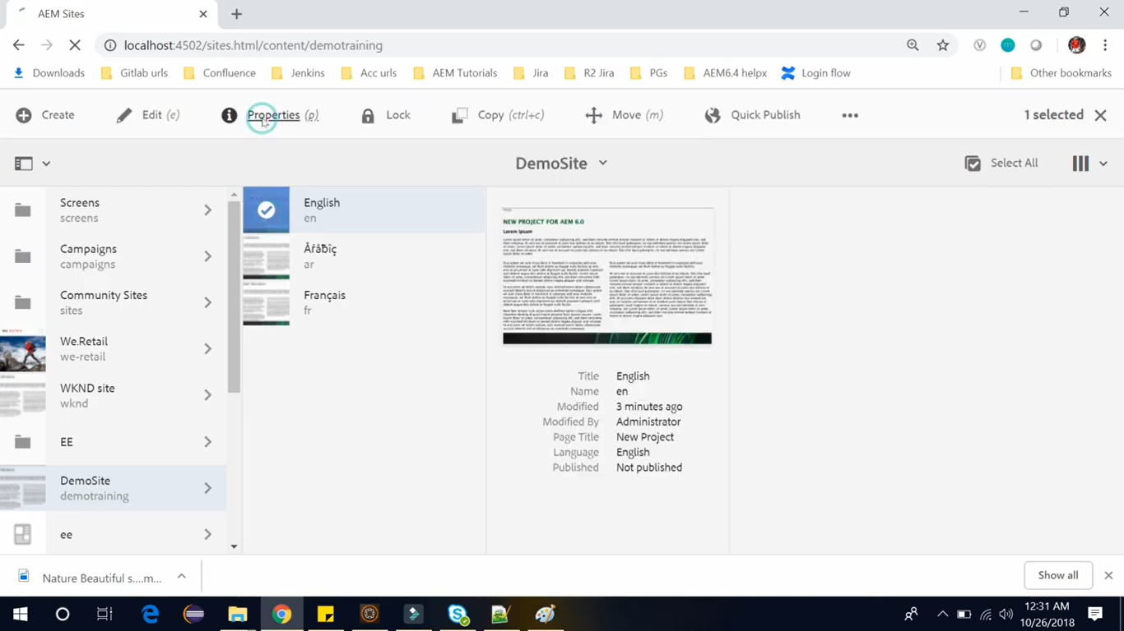

Go to Advance tab --> Scroll down --> Click on **Add Allowed Templates** (image below) and write a path of your template which you just have created.

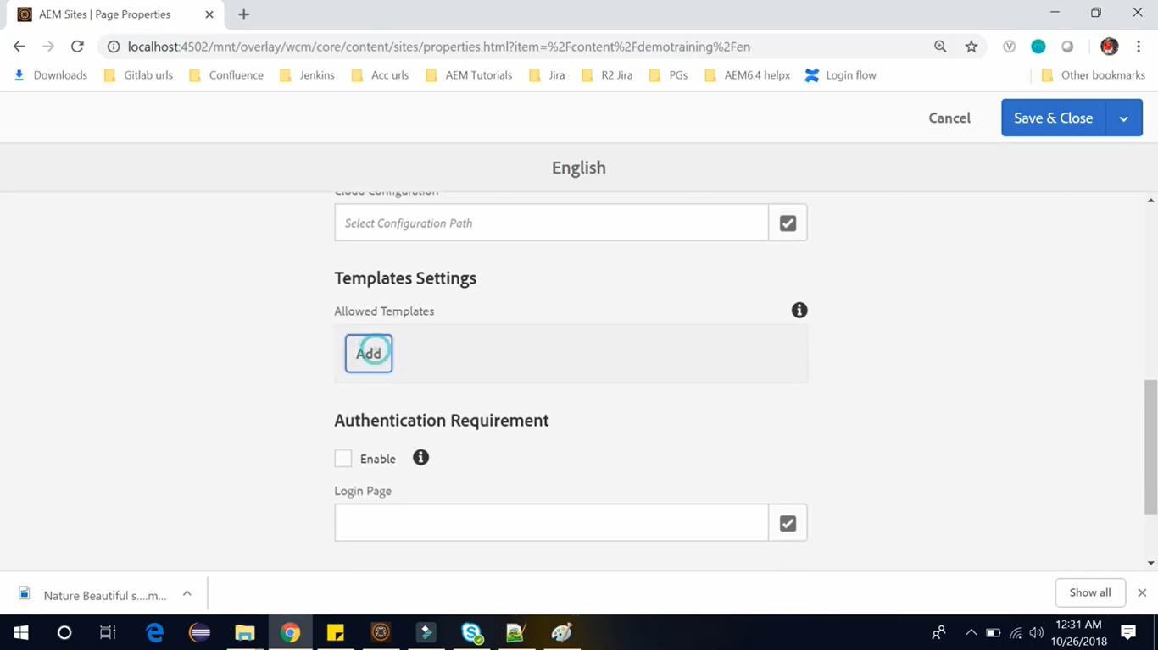

Go to CRX/DE path **/conf/AEM-tutorial/settings/wcm/templates**.

Copy this path of your template to paste. And end it with  **/.\*** Save and Close.

**/.\*** means all the **Templates** available under that path, we can use it while creating **Page**.

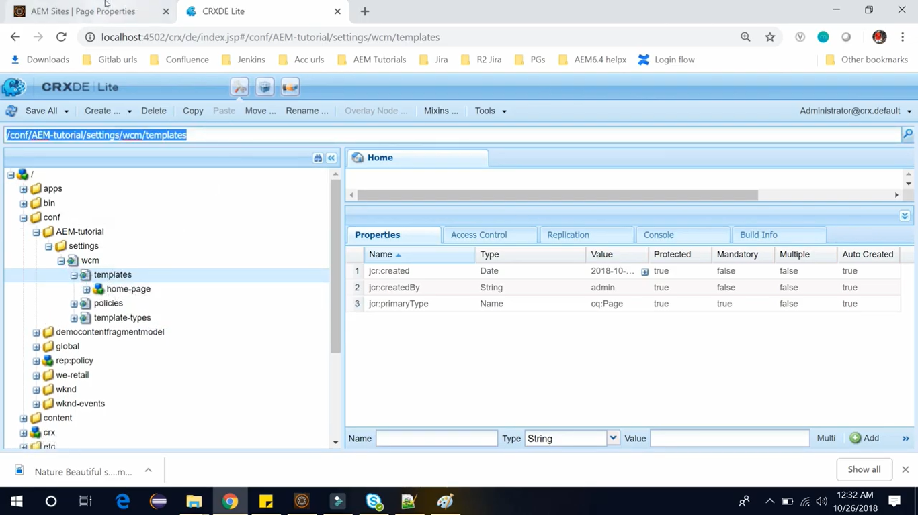

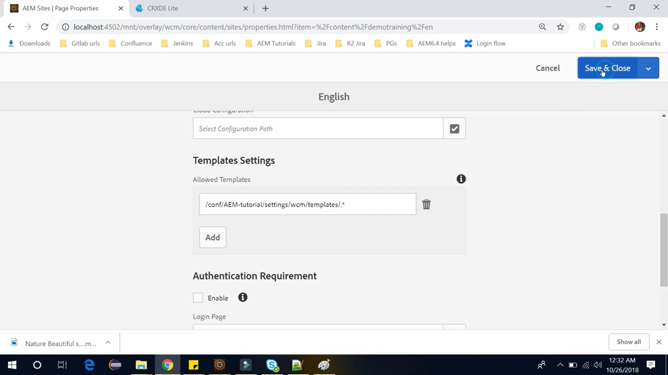

Now go back to Sites Console --> Select **DemoSite** site --> select **English** Page --> **Create** button --> **Page**

Now, you can see **Page** option in the create list which was unavailable earlier.

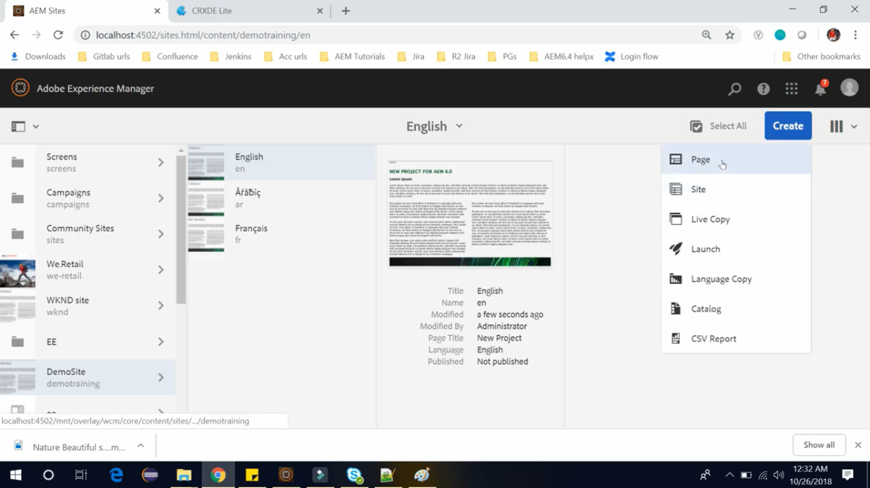

Now, we should see our home page template.

Select **Home Page** template --> click **Next** button --> Set “first page” as **Title** --> click **Create** --> click **Open**

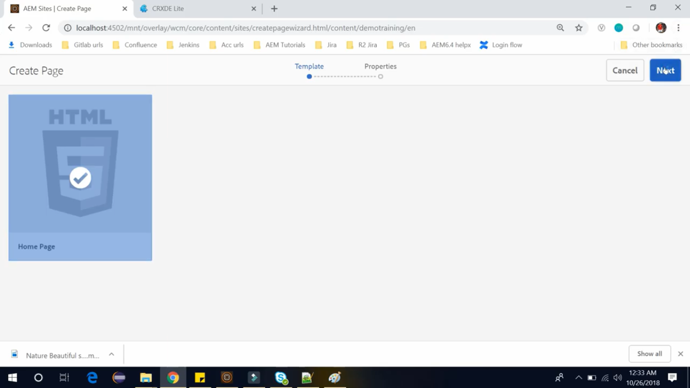

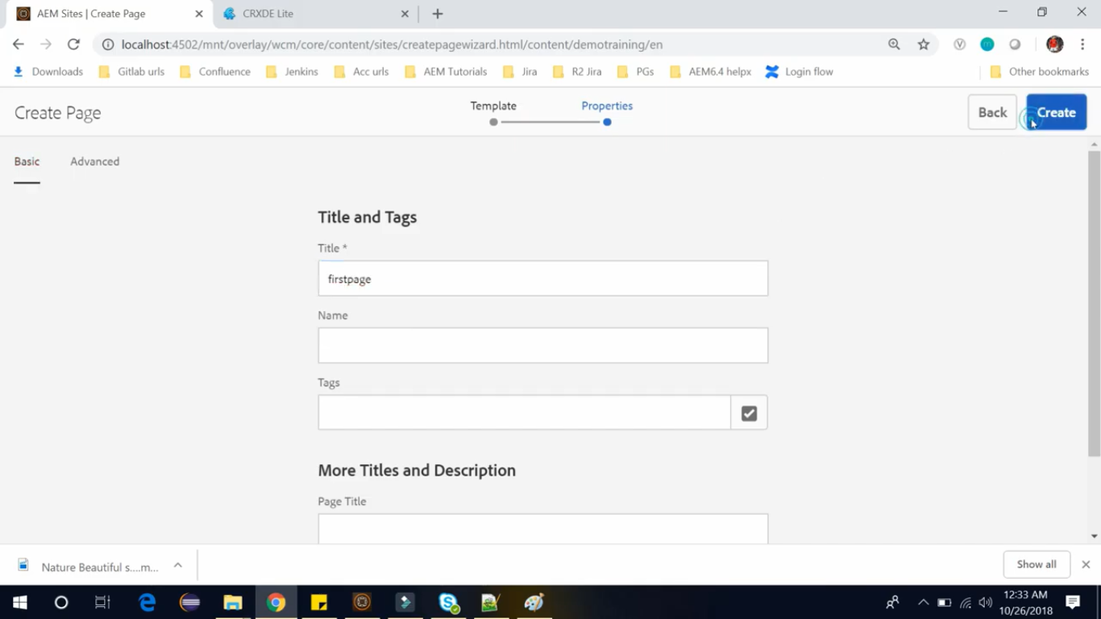

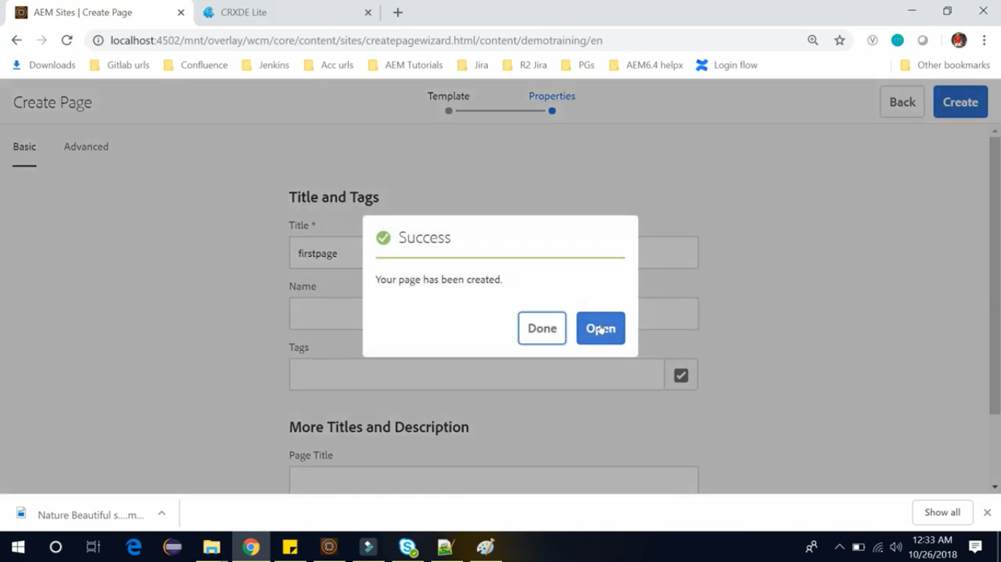

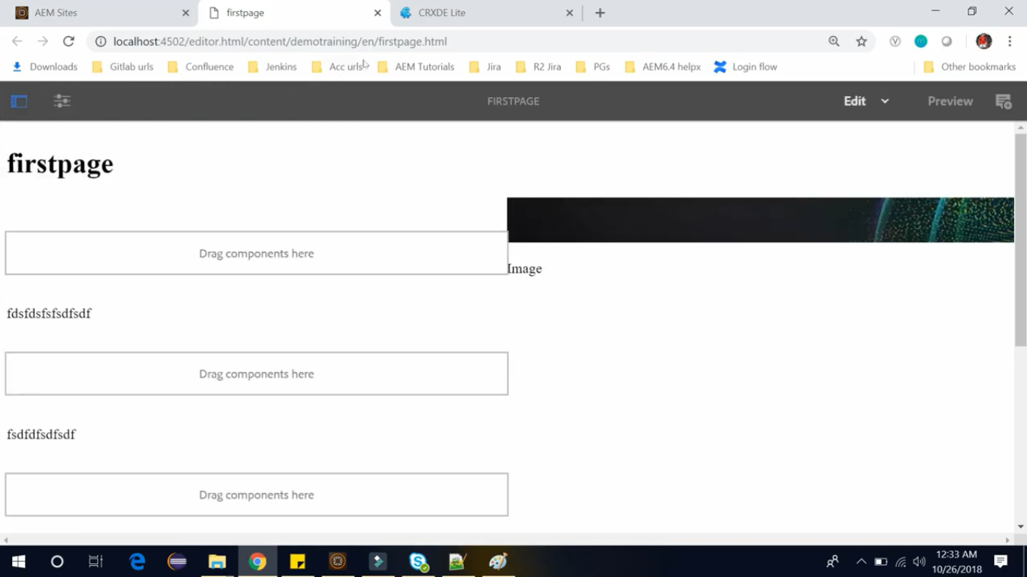

Now we can see, **Title of the Page**, that is, our **firstpage** with all the other components.

So, on below 2 components we unlocked and **added policies** like video and Images.

So, we can add **video** for that **first** component and **Image** for **second** component (see images below).

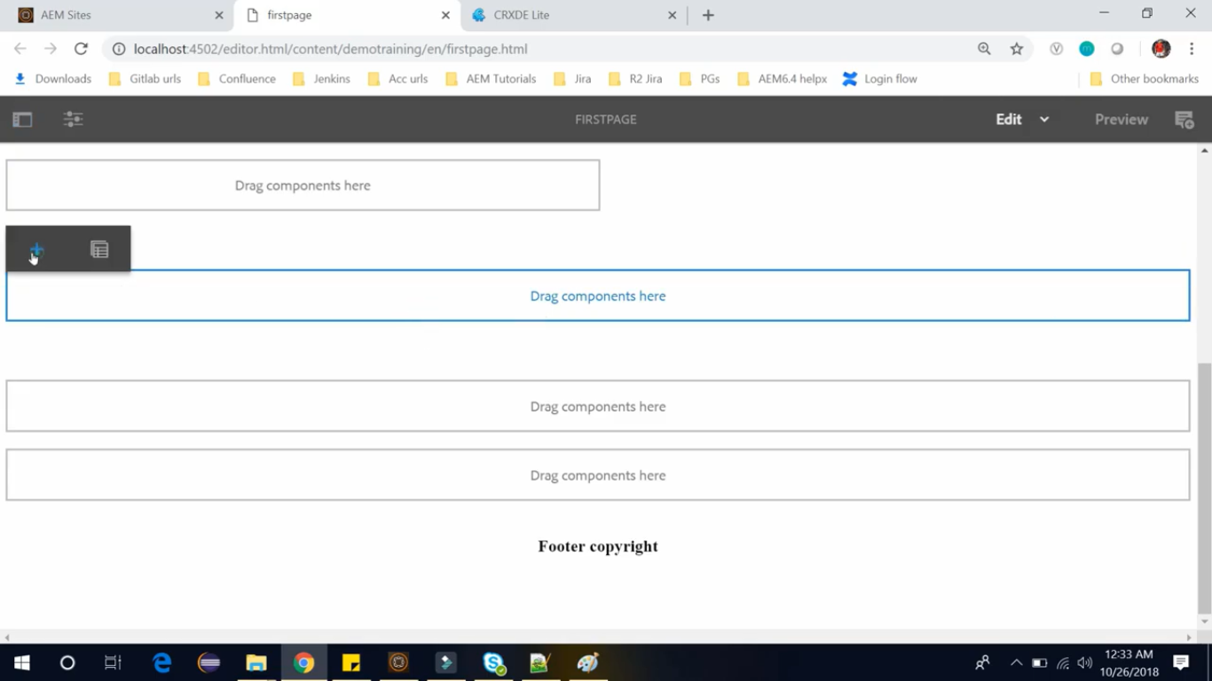

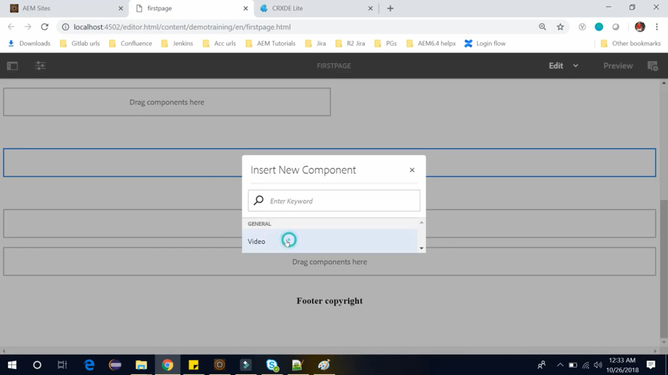

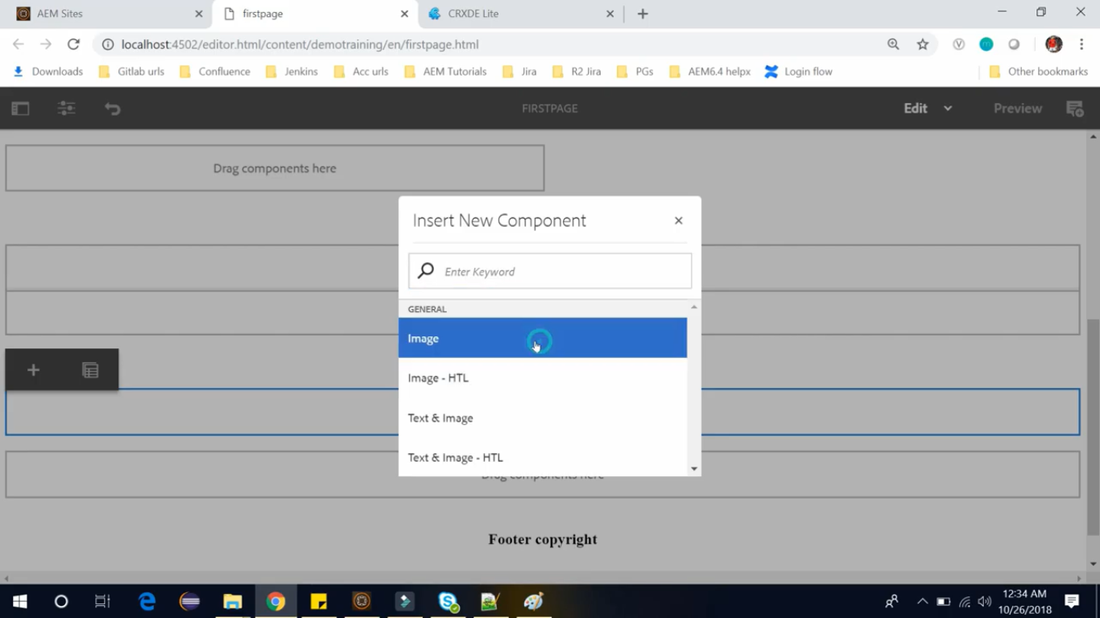

We can drag and drop images here.

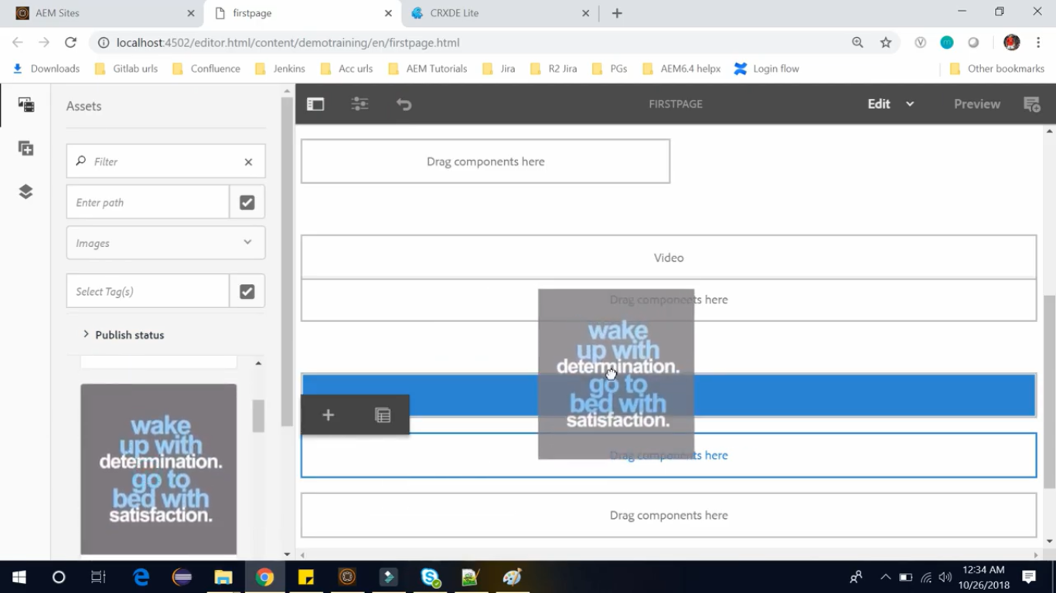

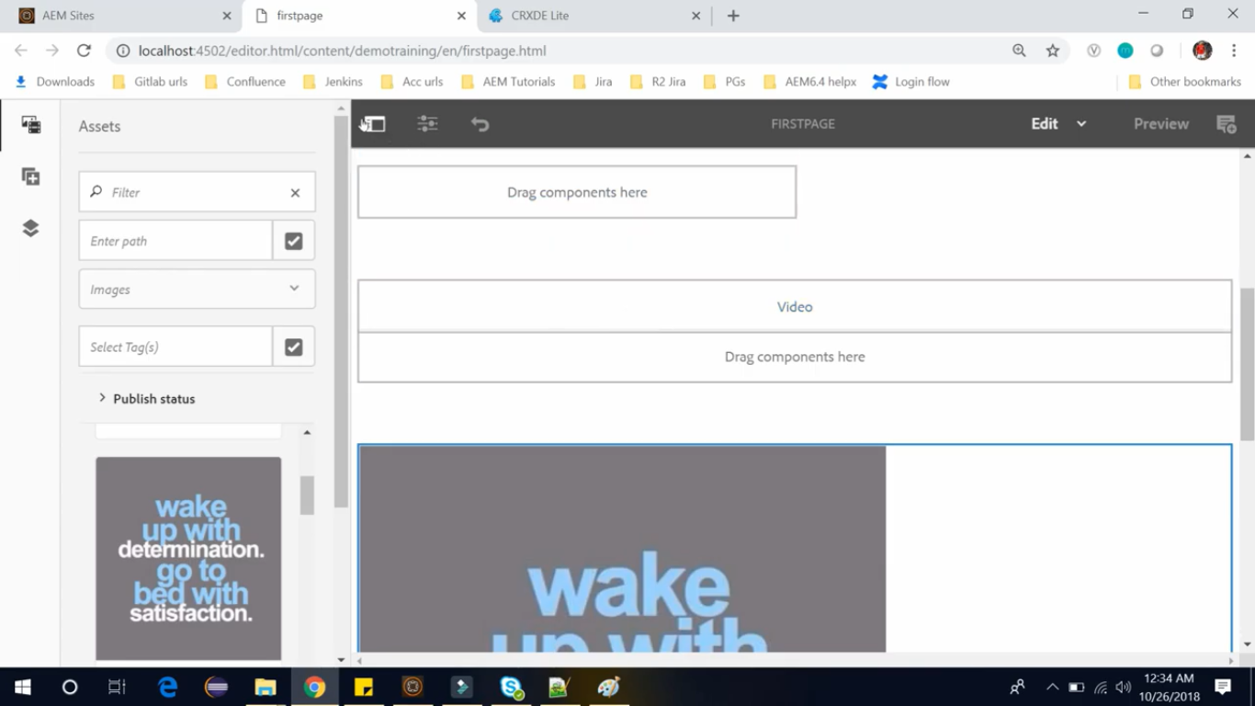

If you want to view how the page looks, then click on **Preview** button on Toolbar (see image below)

